August-November 2024
CS616: Statistical Pattern Recognition
CS612: Statistical Pattern Recognition Laboratory
Programming Assignment 3 Report

Submitted by Group 03

Pawan Ram Mali (PhD) | Abhishek Sharma (MS) | Sachin Maurya (MS)
Department of CSE  Indian Institute of Technology | Department of CSE  Indian Institute of Technology | Department of CSE  Indian Institute of Technology
Dharwad, India | Dharwad, India | Dharwad, India
cs24dp011@iitdh.ac.in | cs24ms003@iitdh.ac.in | cs24ms002@iitdh.ac.in

Contents
1. Introduction 4
2. Dataset Description 5
Dataset 1: 1D Univariate Data 5
Dataset 2: 2D Bivariate Data 5
3. Methodology 5
3.1. Polynomial Regression (for 1D Data) 6
3.1.1 Model Overview 6
3.1.2 Regularization to Prevent Overfitting 6
3.1.3 Cross-Validation for Model Complexity and Regularization 6
3.1.4 Training and Optimization 6
3.1.5 Evaluation Metrics 7
3.2. Gaussian Basis Linear Regression (for 2D Bivariate Data) 7
3.2.1 Model Overview 7
3.2.2 Determining Basis Centers with K-means Clustering 7
3.2.3 Regularization to Improve Generalization 8
3.2.4 Training and Optimization 8
3.2.5 Evaluation Metrics 8
3.3 Cross-Validation for Hyperparameter Tuning 8
3.4 Graphical Analysis and Performance Plots 9
4. Implementation for Dataset 1 – Univariate Data 10
Visualizing data using Scatter Plot 10
Observations from Figure 1 10
Implementing Polynomial Curve Fitting 11
Creating Training Subsets: 11
Looping Through Polynomial Degrees: 11
Fitting the Model: 11
Plotting the Polynomial Fit: 11
Final Visualization: 12
Observations 14
Inferences 15
Implementing Regularization with Ridge Regression 16
Implementation 16
Observations 20
Inferences 20
Implementing cross-validation Mean Squared Error 21
Observations 24
Inferences 24
Final Model Evaluation with Polynomial Degree and Regularization 25
Observations 28
Inferences 28
5. Implementation for Dataset 2 – Bivariate Data 29
Inferences from Each Plot: 30
Conclusion 32
Inferences from Each Plot: 33

List of Figures

Figure 1 Scatter Plot on Training Data 12
Figure 2 Polynomial Curve Fitting with Training Set Size = 10 14
Figure 3 Polynomial Curve Fitting with Training Set Size = 100 15
Figure 4 Polynomial Curve Fitting with Training Set Size = 50 15
Figure 5 Polynomial Curve Fitting with Training Set Size = 700 16
Figure 6 Impact of Regularization on Polynomial Degree 2 19
Figure 7 Impact of Regularization on Polynomial Degree 3 19
Figure 8 Impact of Regularization on Polynomial Degree 8 20
Figure 9 Impact of Regularization on Polynomial Degree 5 20
Figure 10 Impact of Regularization on Polynomial Degree 9 21
Figure 11 24
Figure 12 24
Figure 13 25
Figure 14 25
Figure 15 28
Figure 16 Scatter Plot for Target vs Model Output 29
Figure 17 32

Introduction

In this assignment, we explore regression techniques on synthetic datasets using methods from statistical pattern recognition. The primary objective is to implement models from scratch, without relying on high-level libraries, to gain a deep understanding of regression techniques and the trade-offs involved in model complexity and regularization.
We focus on two distinct models across different types of datasets:
- Polynomial Curve Fitting: Applied to 1-dimensional synthetic data, this model allows us to explore the impact of polynomial degree on model flexibility and overfitting. By varying the polynomial order, we investigate how model complexity affects training and generalization errors, and we apply regularization to control overfitting for high-complexity models.
- Gaussian Basis Linear Regression: Applied to a 2-dimensional dataset, this model employs Gaussian basis functions with centers derived from clustering. Using the K-means algorithm, we determine cluster centers and use these as centers for Gaussian basis functions. This approach enables us to control model complexity through the number of basis functions and to apply regularization for enhanced generalization.
The report provides an in-depth comparison of models based on their training and testing performance, alongside graphical representations of approximated functions, decision regions, and error metrics. By analyzing these models, we aim to understand the trade-offs between model complexity, regularization, and generalization in regression tasks.

Dataset Description

This study utilizes two datasets: a 1D synthetic dataset for polynomial regression and a 2D dataset for Gaussian basis regression.

Dataset 1: 1D Univariate Data
This synthetic dataset is generated from a sinusoidal function with added Gaussian noise, simulating real-world data with inherent noise. The dataset contains a series of observations of a single variable x, paired with target values t generated by applying the function t = sin(2πx) + noise. The objective is to fit a polynomial function to this data, exploring the effects of polynomial degree on model flexibility and generalization. The data is divided into a 70% training and 30% testing split to evaluate model performance on unseen data.

Dataset 2: 2D Bivariate Data
This dataset consists of bivariate data observations, divided into training (70%) and testing (30%) sets. The 2D data will be used to implement Gaussian basis regression, with centers of the Gaussian basis functions determined by K-means clustering on the training data. The dataset allows us to evaluate model complexity by adjusting the number of basis functions and applying regularization to control overfitting. Gaussian basis functions are expected to capture underlying patterns in the data by concentrating the model's focus around dense data regions, identified through clustering.
In the following sections, we delve into the methodology and implementation details for each dataset, presenting results through graphical representations and analyzing model performance metrics across different levels of complexity and regularization.

Methodology

In this assignment, we use Polynomial Regression for 1-dimensional data and Gaussian Basis Linear Regression for 2-dimensional data. The primary objective is to explore the effects of model complexity and regularization on regression performance, particularly how these factors influence generalization. Below is a step-by-step breakdown of the methodology, covering data preprocessing, model training, parameter selection via cross-validation, and performance analysis.

3.1. Polynomial Regression (for 1D Data)

3.1.1 Model Overview
Polynomial regression is a form of linear regression where the model fits a polynomial function of degree $M$ to the data. By varying the degree $M$, we can increase or decrease the model's flexibility:
- Low-degree polynomials produce simpler models that may underfit the data.
- High-degree polynomials allow for more flexibility but can lead to overfitting.
The model is expressed as:
$$y\left(x,w\right)=w_{0}+w_{1}x+w_{2}x^{2}+…+w_{M}x^{M}=\sum_{j=0}^{M}{w_{j}x^{j}}$$
where $M$ represents the polynomial degree, and$w_{j}$​ are the weights or coefficients to be learned from the training data.

3.1.2 Regularization to Prevent Overfitting
To prevent overfitting in high-degree polynomials, we apply regularization (ridge regression). Regularization penalizes large weight values, effectively smoothing the model and reducing overfitting.
The regularized objective function is:
$$E_{\text{reg}}\left(w\right)=\frac{1}{2N}\sum_{n=1}^{N}{{\left(y\left(x_{n},w\right)-t_{n}\right)}^{2}}+\frac{λ}{2}\sum_{j=0}^{M}{w_{j}^{2}}$$
where $λ$ is the regularization parameter. When $λ$ = 0, the model behaves like standard polynomial regression without regularization. As $λ$ increases, the model becomes more constrained, which can help control overfitting.

3.1.3 Cross-Validation for Model Complexity and Regularization
We use cross-validation to select the optimal:
- Polynomial degree $M$: Values of $M$ range from 2 to 9 to study the effect of model complexity.
- Regularization parameter $λ$: Cross-validation helps determine the best $λ$ value to balance fit quality and generalization.

3.1.4 Training and Optimization
- Objective Function: The model minimizes the mean squared error (MSE), defined as:
$$E\left(w\right)=\frac{1}{2N}\sum_{n=1}^{N}{{\left(y\left(x_{n},w\right)-t_{n}\right)}^{2}}$$
When regularization is applied, this is modified to $E_{reg}\left(w\right)$as shown above.
- Weight Estimation: The model weights $\left(w\right)$ are computed using closed-form solutions available for both polynomial regression and regularized polynomial regression.

3.1.5 Evaluation Metrics
The model's performance is evaluated using:
- Mean Squared Error (MSE) on both training and test datasets.
- Root Mean Squared Error (RMSE) to allow easy comparison across different model configurations.

3.2. Gaussian Basis Linear Regression (for 2D Bivariate Data)

3.2.1 Model Overview
Gaussian Basis Linear Regression is a type of linear regression that transforms the input data using Gaussian basis functions centered around key points in the data. This technique allows for capturing non-linear relationships by transforming the input space.
The model is expressed as:
$$y\left(x,w\right)=\sum_{j=1}^{M}{w_{j}ϕ_{j}\left(x\right)}$$
where $ϕ_{j}\left(x\right)=\exp\left(-\frac{|x-μ_{j}|^{2}}{2σ^{2}}\right)$ represents the Gaussian basis function centered at $μ_{j}$, and $σ$ is a spread parameter. $M$ is the number of basis functions, which is a key complexity parameter in the model.

3.2.2 Determining Basis Centers with K-means Clustering
To position the Gaussian centers $μ_{j}$​ effectively:
- K-means Clustering: We use K-means clustering on the training data to determine $M$ cluster centers. These cluster centroids serve as the centers of our Gaussian basis functions.
- Model Complexity (Number of Basis Functions): We vary $M$ to study the impact of model complexity. Tested values include $M$ = 2,4,8,16,32,128 and 256.

3.2.3 Regularization to Improve Generalization
Like polynomial regression, Gaussian basis regression can overfit when the number of basis functions $M$ is high. We apply L2 regularization to the model weights to improve generalization. The regularized objective function is:
$$E_{\text{reg}}\left(w\right)=\frac{1}{2N}\sum_{n=1}^{N}{{\left(y\left(x_{n},w\right)-t_{n}\right)}^{2}}+\frac{λ}{2}|w|^{2}$$
where $λ$ controls the regularization strength. Cross-validation is used to determine the best $λ$ value for each model configuration.

3.2.4 Training and Optimization
- Objective Function: The model minimizes the mean squared error $E\left(w\right)$, modified with regularization as shown above.
- Weight Estimation: The weights are computed using closed-form solutions, leveraging the linear structure of the Gaussian basis expansion.

3.2.5 Evaluation Metrics
We evaluate the model using:
- MSE and RMSE on both training and test datasets to assess generalization and fit quality.
- Scatter Plots of Model Output vs Target Output for both datasets to visualize how well the model captures the data patterns.
- Decision Region and Contour Plots to visualize the Gaussian basis model’s decision boundaries, which show how well the model captures regions of high density in the data.

3.3 Cross-Validation for Hyperparameter Tuning
Cross-validation is employed to select:
- Model Complexity:
  - Degree $M$ for polynomial regression.
  - Number of basis functions $M$ for Gaussian basis regression.
- Regularization Parameter λ: Cross-validation is used to find the optimal regularization strength for each configuration, balancing the trade-off between model fit and generalization.

3.4 Graphical Analysis and Performance Plots
We include several plots to assess model behavior:
- MSE and RMSE vs. Model Complexity: To analyze the effect of increasing model flexibility on training and test error.
- Model Output vs Target Output Scatter Plots: To compare the predicted vs actual values, visualizing the fit quality.
- Decision Region and Contour Plots (for Gaussian basis model): These plots allow for visualization of how well the model captures different regions in the input space.
These analyses provide insights into how model complexity and regularization affect the performance and generalization of the models. The methodology emphasizes closed-form solutions and cross-validation to balance the complexity and regularization for optimal performance on unseen data.

Implementation for Dataset 1 – Univariate Data

Visualizing data using Scatter Plot

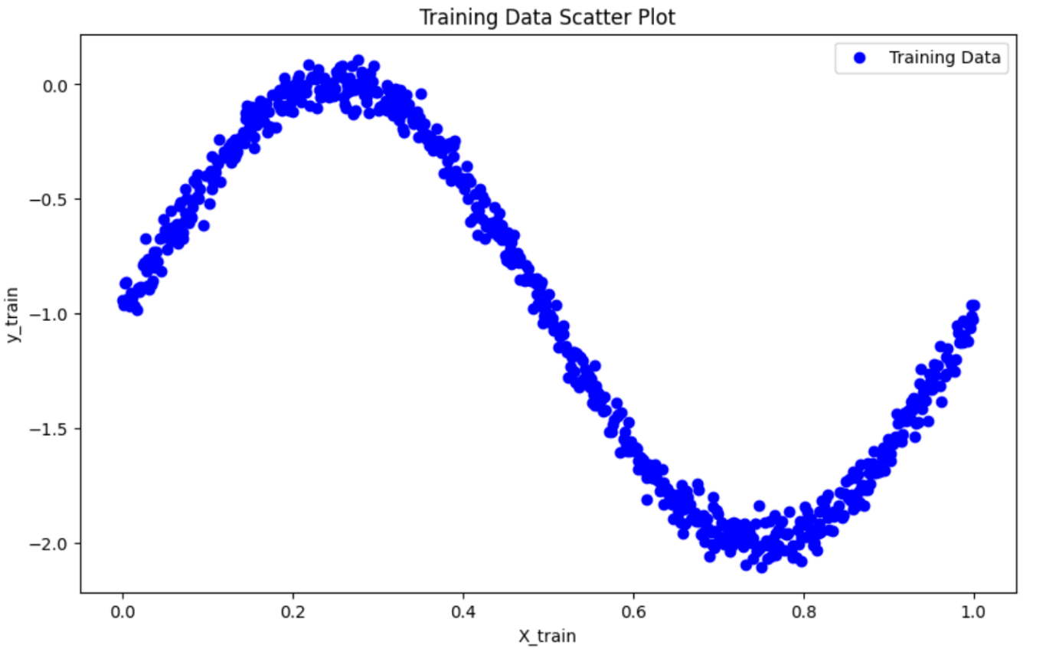
Figure 1 Scatter Plot on Training Data

Observations from Figure 1

- The scatter plot displays the relationship between the independent variable (X_train) and the dependent variable (y_train) in the training dataset.

- This initial visualization gives a clear view of the data distribution and any apparent relationship between ( X ) and ( y ). For polynomial regression, we're interested in seeing if the data might follow a curved pattern rather than a straight line, which would suggest a non-linear relationship.

Implementing Polynomial Curve Fitting

Creating Training Subsets:
  - We define multiple subset sizes stored in a list called subset_sizes, which includes values [10, 50, 100, and the full training set length].
  - For each size in subset_sizes, we create a subset of the training data by selecting the first size rows from the full training set (X_train_full and y_train_full). This step allows us to observe the impact of training subset size on the model’s ability to fit polynomial curves.
  - These subsets are used to investigate how model performance and overfitting behavior change with different amounts of data.

Looping Through Polynomial Degrees:
  - For each training subset, we vary the polynomial degree from 2 to 9 to study the effect of model complexity.
  - We create polynomial features using PolynomialFeatures(degree=degree), which transforms the independent variable X into polynomial terms up to the specified degree. For example, a degree-2 polynomial will include an X^2 term, a degree-3 polynomial will add both X^2 and X^3 terms, and so on.

Fitting the Model:
  - After transforming X values to polynomial features, we use LinearRegression to fit the model on the transformed data (X_train_poly) and the subset target values (y_train_subset).
  - The model is trained to minimize the error for the specified polynomial degree, creating a polynomial fit for each degree.

Plotting the Polynomial Fit:
  - To visualize the fit, we generate a range of X values (X_range) covering the entire span of the training data.
  - We transform X_range with polynomial features and use the model to predict the corresponding y-values (y_pred). This step allows us to plot a smooth curve representing each polynomial fit.
  - Each plot includes:
    - Scatter Points for the original training subset, showing actual data points.
    - Polynomial Curves for each degree (from 2 to 9), with labels for easy comparison.
  - Plot Insertion: Each subset size has a dedicated plot showing polynomial fits for degrees 2 through 9. The plot title specifies the subset size, and a legend labels each polynomial degree.

Final Visualization:
  - For each subset size, a plot visualizes polynomial fits across degrees 2 through 9, allowing a comparison of model complexity’s impact on fit quality.
  - Titles indicate the subset size, and legends label polynomial degrees for clear distinction.
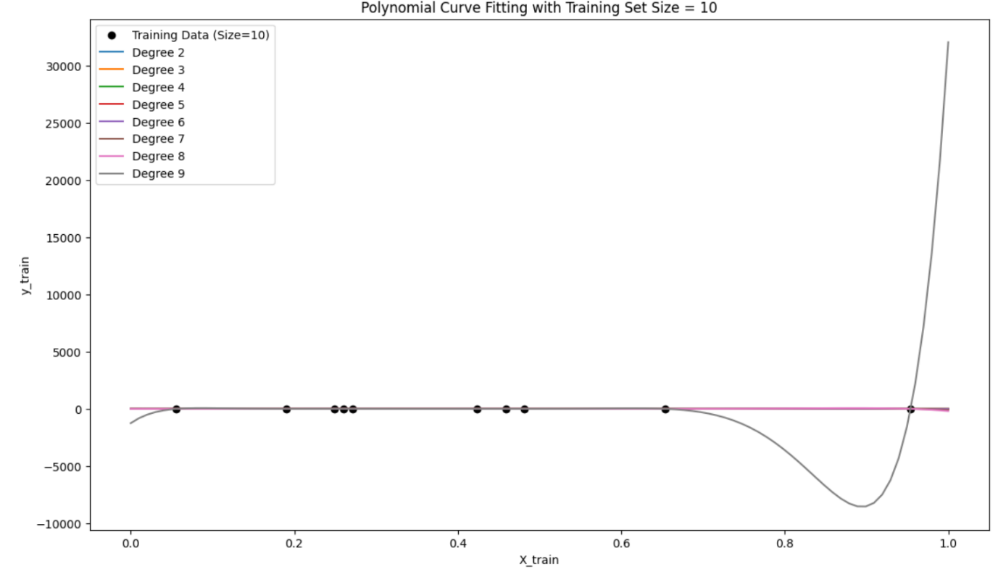
Figure 2 Polynomial Curve Fitting with Training Set Size = 10

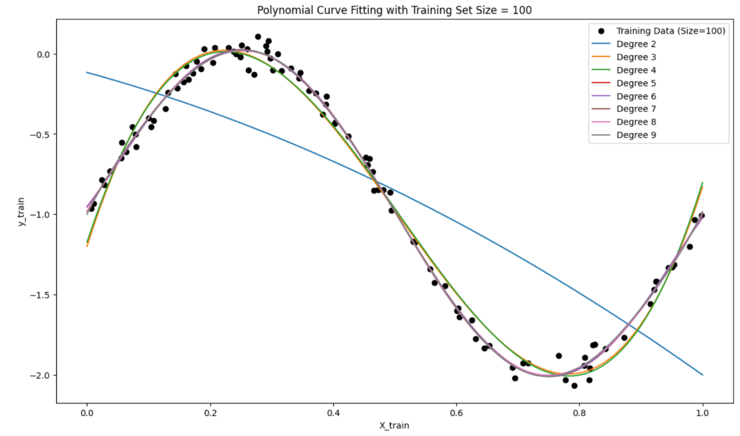
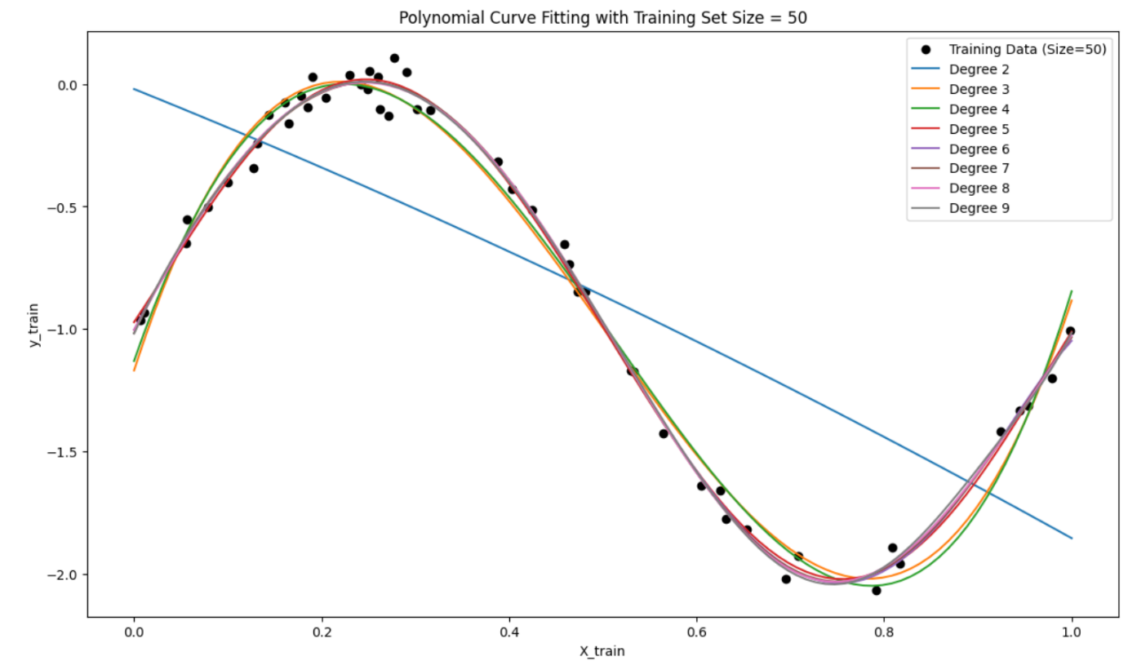
Figure 3 Polynomial Curve Fitting with Training Set Size = 100
Figure 4 Polynomial Curve Fitting with Training Set Size = 50

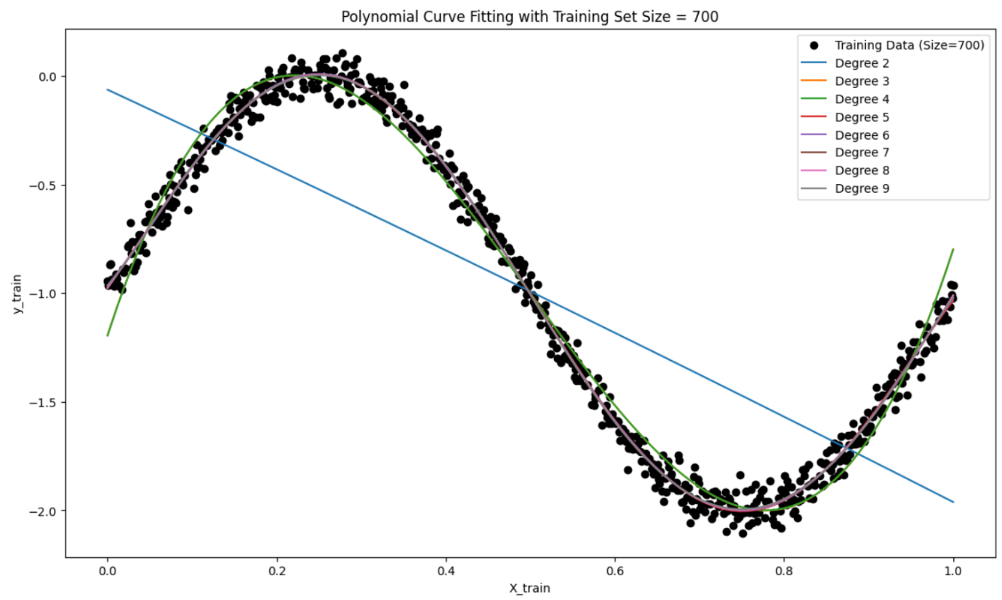
Figure 5 Polynomial Curve Fitting with Training Set Size = 700

Observations
- Effect of Training Data Size:
  - Small Subsets (10 and 50): With fewer data points, higher-degree polynomials often overfit, as they attempt to fit each point exactly. This overfitting leads to wavy, overly complex curves that do not generalize well.
  - Larger Subsets (100 and Full Set): As the subset size increases, the models begin to capture the general trend more accurately, particularly with lower-degree polynomials. Overfitting becomes less pronounced for higher degrees, as the model has more data to learn the underlying trend.
- Impact of Polynomial Degree:
  - Low Degree (2 to 3): Lower-degree polynomials generally produce smoother, more generalized fits, capturing the overall trend of the data. They are effective across all subset sizes, especially when the data has a simpler underlying structure.
  - Medium Degree (4 to 6): These degrees capture moderate data complexity, balancing trend capture without excessive oscillation. They are effective in representing the underlying pattern without overfitting.
  - High Degree (7 to 9): Higher-degree polynomials often capture small variations and oscillations, which may not represent the true trend. Overfitting is particularly evident in smaller subsets, where the polynomial curves oscillate to match each data point.

Inferences
- Model Complexity and Overfitting:
  - Higher-degree polynomials introduce more flexibility, allowing the model to fit the data closely, but they are prone to overfitting, especially on smaller subsets. Selecting an appropriate polynomial degree depends on the dataset size and complexity.
  - Cross-validation is essential to select the best degree that balances bias (underfitting) and variance (overfitting), allowing the model to generalize well to unseen data.
- Importance of Training Data Size:
  - When data points are limited, higher-degree polynomials tend to overfit, while lower-degree models produce smoother, more stable fits. As the subset size grows, higher degrees start to fit the true pattern better, highlighting the importance of sufficient data to avoid overfitting.
  - Regularization (e.g., Ridge regression) could help control overfitting for higher degrees, especially on smaller subsets or noisier data.
- Bias-Variance Trade-Off:
  - This implementation illustrates the bias-variance trade-off in polynomial regression, where low-degree models may underfit, and high-degree models can overfit. The balance between complexity and generalization depends on the subset size and underlying data structure, emphasizing the need for model complexity tuning and data sufficiency.

Implementing Regularization with Ridge Regression
To further improve the polynomial regression model's generalization, we implement Ridge regression, a regularization technique that penalizes large coefficient values, helping control model complexity, especially for high-degree polynomials.

Implementation
- Applying Ridge Regularization:
  - For each polynomial degree from 2 to 9, we apply Ridge regression with different regularization strengths, denoted by alpha values (0.001, 0.01, 0.1, 1, and 10).
  - Alpha Values: Smaller alpha values indicate less regularization, allowing the model more flexibility, while larger values impose stronger regularization, reducing coefficient magnitudes and, consequently, the model’s complexity.
- Fitting Polynomial Models:
  - We transform the training data (X_train_full) into polynomial features for each degree using PolynomialFeatures. This transformation enables fitting polynomial models of increasing complexity, capturing non-linear relationships as the polynomial degree grows.
- Recording Model Coefficients:
  - After fitting each model, we store the coefficients for each alpha value. Ridge regression penalizes larger coefficients, so examining how these coefficients vary with different alpha values and polynomial degrees helps illustrate regularization’s impact on model flexibility.
- Plotting the Fitted Curves:
  - For each polynomial degree, we create plots showing the fitted curves for different alpha values alongside the training data points. This allows a visual comparison of how the polynomial fits become smoother and less flexible as regularization strength increases.
  - Plot Insertion: Insert plots of the fitted curves for each degree, showcasing how different alpha values affect the model’s complexity on the same training data.
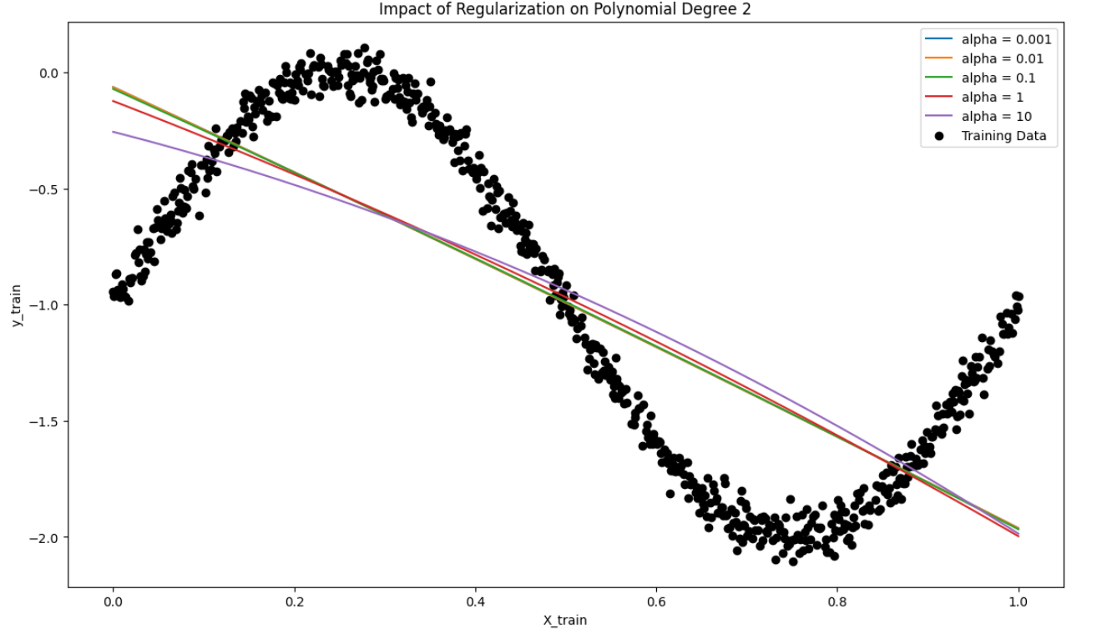
Figure 6 Impact of Regularization on Polynomial Degree 2
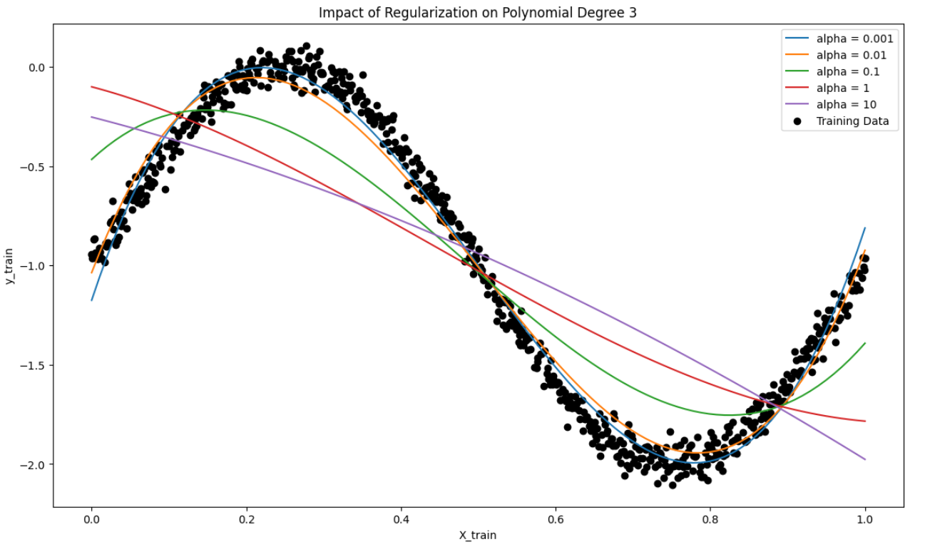
Figure 7 Impact of Regularization on Polynomial Degree 3
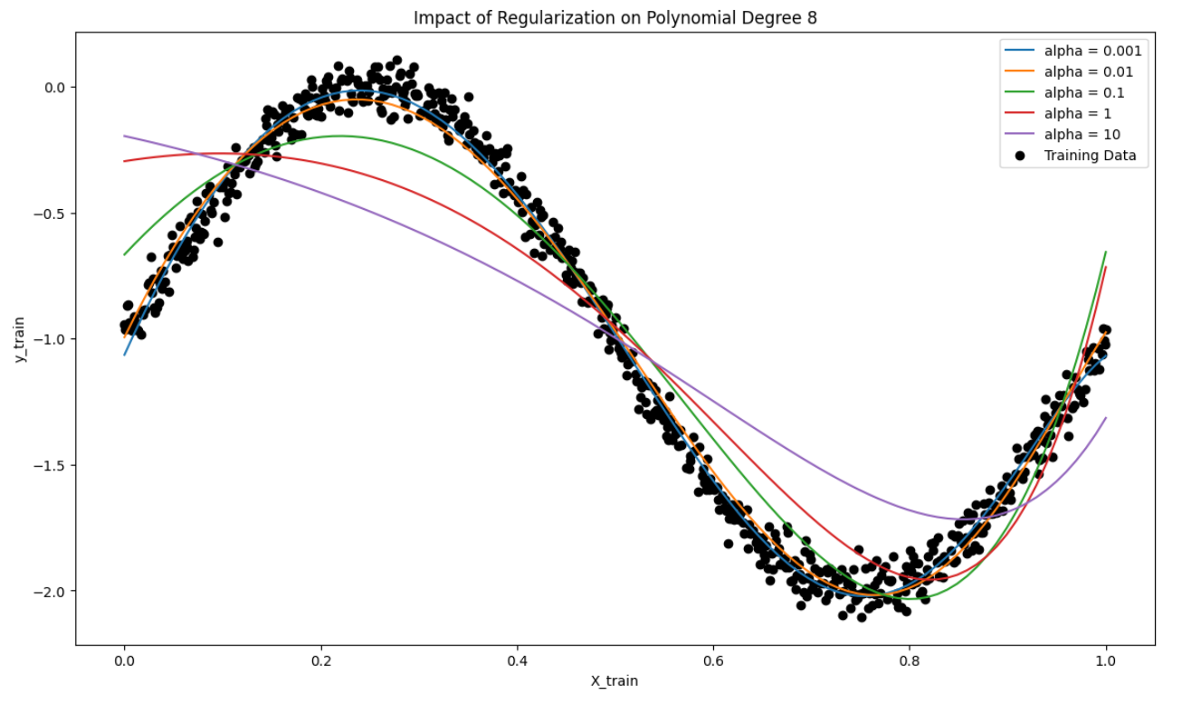
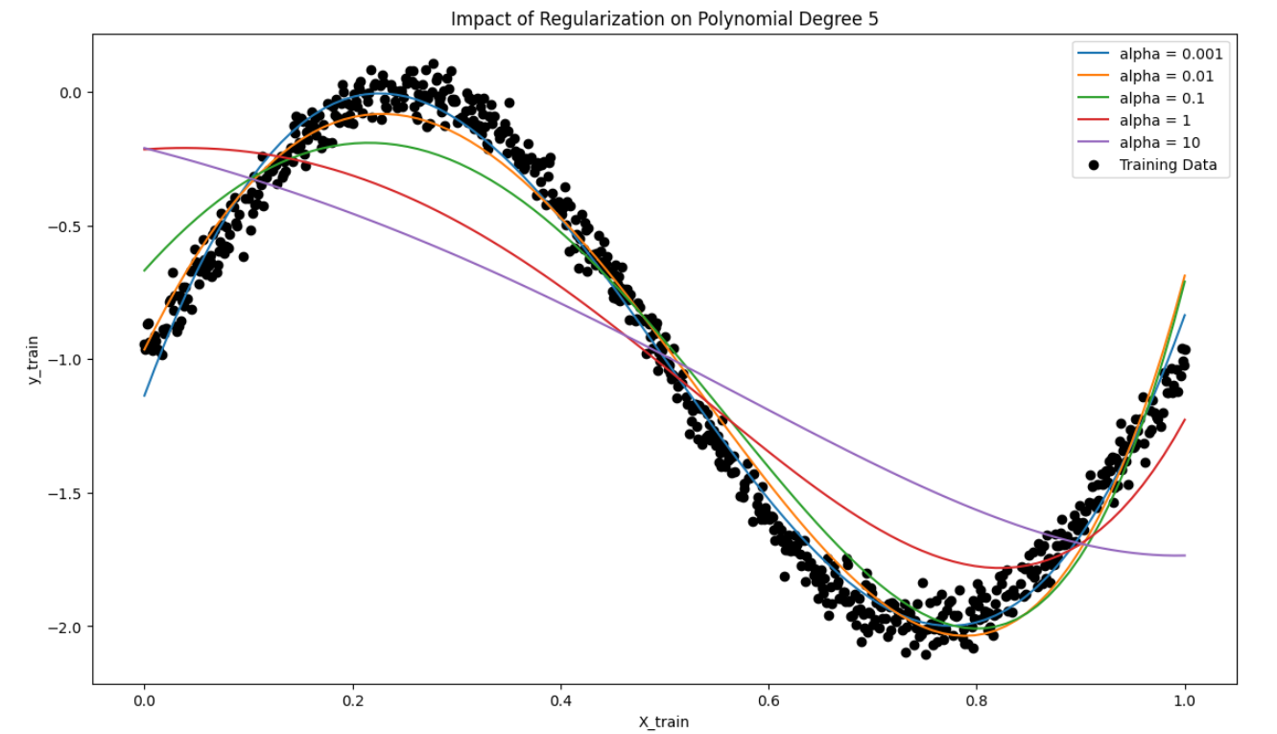
Figure 8 Impact of Regularization on Polynomial Degree 8
Figure 9 Impact of Regularization on Polynomial Degree 5
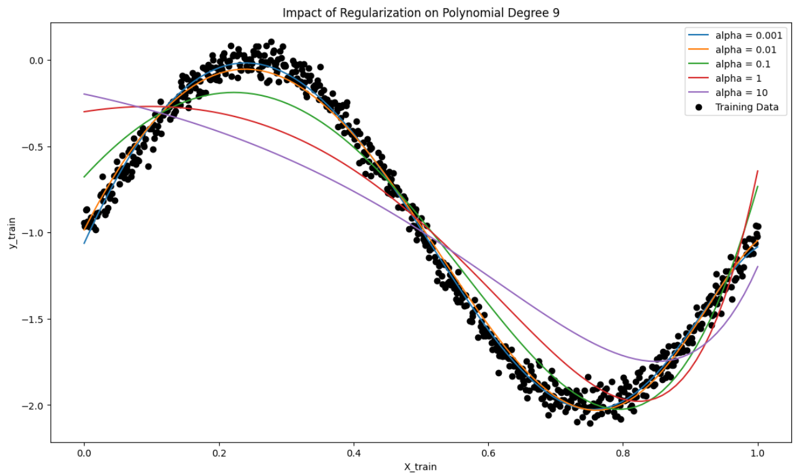
Figure 10 Impact of Regularization on Polynomial Degree 9

Observations
- Effect of Increasing Alpha on Model Complexity:
  - As alpha increases, the polynomial fits become smoother and less flexible, with high-degree polynomials appearing more linear. Regularization reduces the influence of higher-order terms, making the model less prone to overfitting, particularly at higher polynomial degrees.
- Coefficient Shrinkage with Higher Alpha:
  - The coefficient plots indicate that as alpha grows, the magnitude of polynomial coefficients, especially for higher-order terms, decreases. This shrinkage limits the influence of complex terms in the polynomial, helping prevent overfitting by simplifying the model.
- Impact of Polynomial Degree:
  - For lower-degree polynomials (e.g., degree 2 or 3), the effect of regularization is relatively mild because these models are simpler and less likely to overfit. As the polynomial degree increases, regularization has a stronger effect, and higher alpha values lead to smoother curves with reduced oscillations, effectively reducing overfitting.

Inferences
- Bias-Variance Trade-Off:
  - Regularization helps balance the bias-variance trade-off in polynomial regression. Lower alpha values allow the model to fit complex patterns but may lead to high variance and overfitting. Higher alpha values, while reducing variance, increase bias as the model becomes overly simplistic and less adaptable to the data’s nuances.
- Optimal Alpha Selection:
  - The ideal alpha value strikes a balance between model flexibility and generalization. Cross-validation can help identify this optimal alpha, ensuring the model fits underlying patterns in the data without overfitting to noise.
- Importance of Regularization for High-Degree Polynomials:
  - Regularization is especially valuable for higher-degree polynomials, which are more prone to overfitting. By penalizing large coefficients, Ridge regression focuses the model on capturing significant data patterns, reducing the risk of overfitting.

Implementing cross-validation Mean Squared Error
- Cross-Validation MSE Calculation:
  - For each combination of training subset size, polynomial degree, and regularization parameter, we use 5-fold cross-validation with cross_val_score to calculate the cross-validation Mean Squared Error (CV MSE).
  - Cross-validation evaluates each model’s generalization ability by splitting the subset into training and validation folds. This approach provides insight into which polynomial degree and alpha value yield the lowest validation error, indicating the best balance between complexity and generalization.
- Training MSE Calculation:
  - Alongside CV MSE, we calculate the training MSE (Train MSE) for each model configuration. This metric shows the model’s accuracy on the training subset, helping us compare training performance against cross-validation performance.
  - Discrepancies between Train MSE and CV MSE reveal important patterns: if Train MSE is significantly lower than CV MSE, the model is likely overfitting, while high errors on both indicate underfitting.
- Storing and Organizing Results:
  - Results for each model configuration are stored in two lists, mse_train_results and mse_cv_results, which are later converted to DataFrames (mse_train_df and mse_cv_df) for convenient access and visualization.
- Plotting Cross-Validation MSE:
  - For each subset size, a plot of CV MSE vs. polynomial degree is created, with separate lines for each alpha value. This visual helps illustrate how model complexity (polynomial degree) and regularization (alpha) affect validation error, aiding in the selection of the optimal degree and alpha that minimize CV MSE.
- Plotting Training MSE:
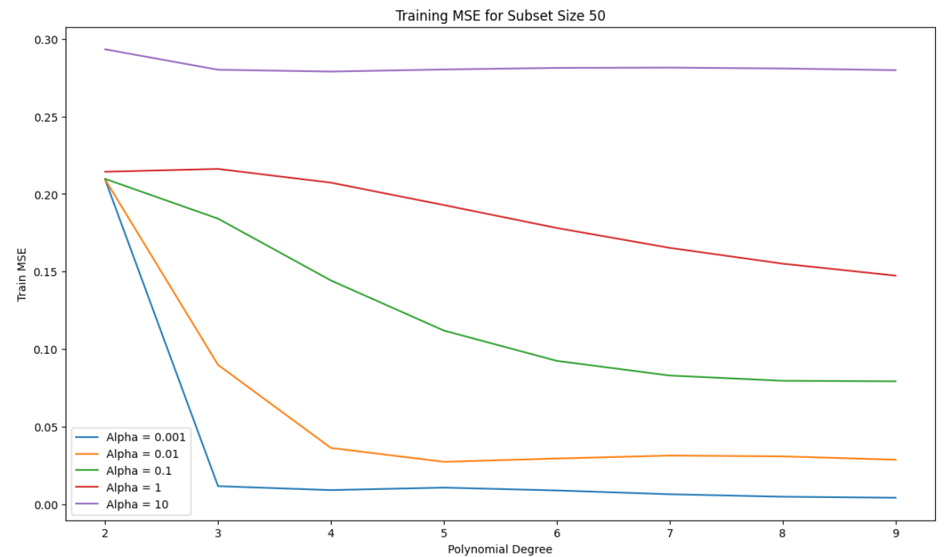
  - Similarly, for each subset size, we plot training MSE vs. polynomial degree with lines for each alpha value. These plots show how training MSE responds to increased polynomial degrees and various alpha values, highlighting any signs of overfitting or underfitting.
Figure 11

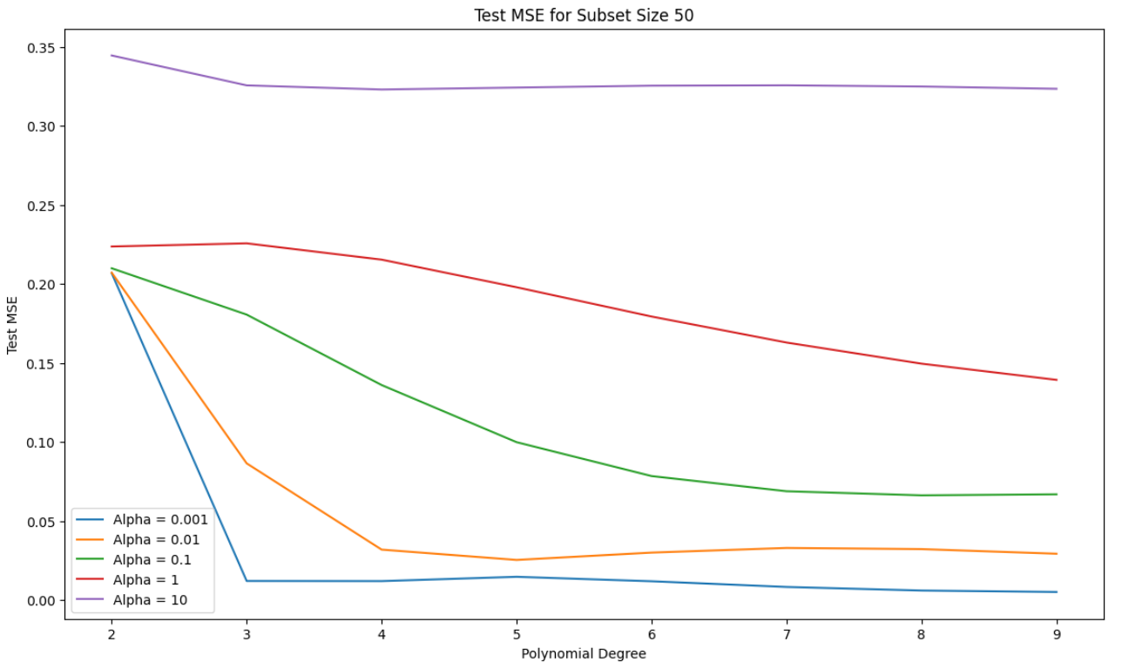
Figure 12
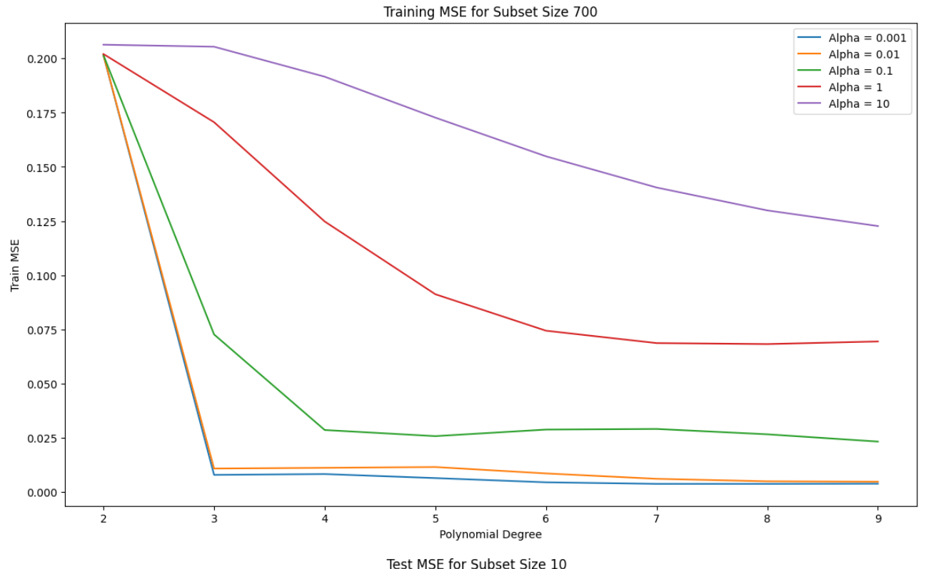
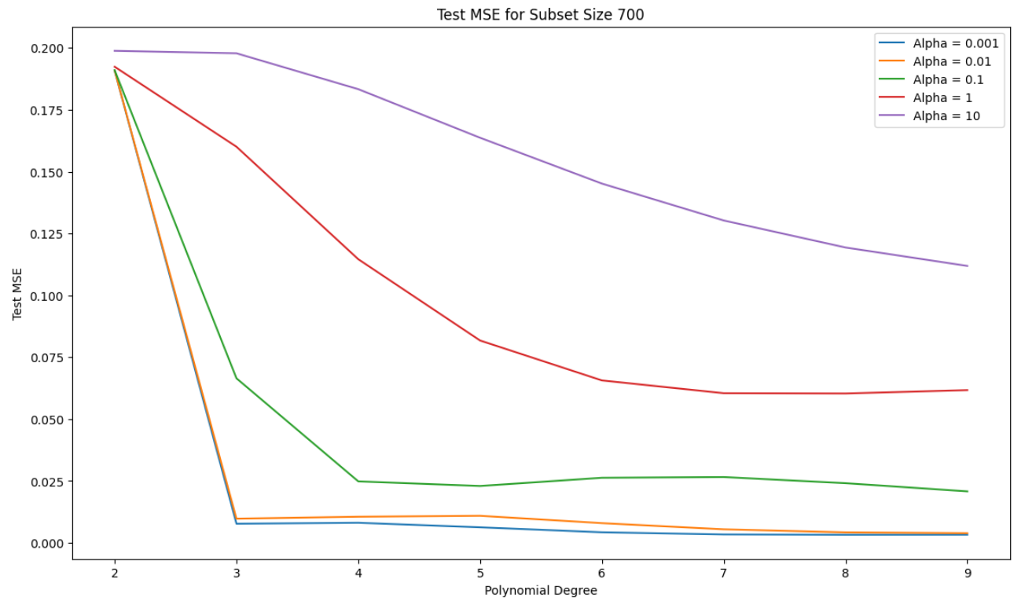
Figure 13
Figure 14

Observations
- Cross-Validation MSE Trends:
  - Low Alpha Values: With low alpha values, higher-degree polynomials often yield lower CV MSE as they fit the data flexibly. However, CV MSE may increase for very high degrees, indicating overfitting where the model becomes overly complex and begins capturing noise in the data.
  - High Alpha Values: For larger alpha values, CV MSE generally stabilizes or increases as polynomial degree grows. This shows that regularization reduces overfitting by limiting the model’s flexibility, particularly at higher degrees.
- Training MSE Trends:
  - Low Alpha Values and High Degrees: At low alpha values, training MSE decreases substantially with increasing polynomial degree as the model captures more data variance. However, when training MSE is much lower than CV MSE, it suggests overfitting.
  - High Alpha Values and Lower Degrees: With higher alpha values, training MSE increases, indicating a reduction in model flexibility. For high degrees, training MSE tends to flatten with large alpha values, showing regularization's role in reducing the impact of higher-degree terms.
- Effect of Subset Size:
  - Small Subsets: For smaller subsets (e.g., size 10), CV MSE remains high across polynomial degrees, highlighting the difficulty in generalizing with limited data. Regularization has a more pronounced effect, as high-degree polynomials tend to overfit small datasets without adequate regularization.
  - Larger Subsets: As subset size increases (50, 100, full set), CV MSE generally decreases, and the optimal polynomial degrees stabilize. With larger datasets, regularization is less critical, as the data quantity itself aids in preventing overfitting.

Inferences
- Optimal Polynomial Degree and Regularization:
  - The best model configuration minimizes CV MSE while keeping Train MSE close to CV MSE, indicating a balanced model that generalizes well. Typically, intermediate polynomial degrees (e.g., 3 to 6) and moderate alpha values achieve the best generalization across subset sizes.
- Importance of Cross-Validation:
  - Cross-validation is crucial for identifying the ideal model complexity and regularization, especially on small subsets prone to overfitting. By testing different combinations of polynomial degrees and alpha values, cross-validation helps select models that generalize better without relying solely on training data performance.
- Regularization’s Impact on High-Degree Polynomials:
  - Regularization is especially valuable for higher-degree polynomials where overfitting is likely. By reducing the influence of high-order terms, larger alpha values improve generalization by shrinking coefficients, thus focusing the model on significant patterns and reducing noise sensitivity.

Final Model Evaluation with Polynomial Degree and Regularization
This section details the final model evaluation process using the optimal polynomial degree and regularization parameter (alpha) obtained from cross-validation. The goal is to validate the model's performance on both training and test data, ensuring that it generalizes well to new, unseen data.

- Transform Data Using Best Polynomial Degree:
  - Using the optimal polynomial degree identified through cross-validation, we transform both the training and test datasets into polynomial features. This transformation enables the model to capture non-linear relationships in the data based on the best-fitting polynomial complexity.
- Fit the Best Model:
  - The Ridge regression model is trained on the transformed training data with the selected regularization parameter (alpha). This alpha value balances model flexibility and regularization, preventing overfitting while retaining sufficient complexity to capture significant patterns in the data.

- Generate Predictions for Training and Test Data:
  - After fitting the model, predictions are generated for both training (y_train_pred) and test datasets (y_test_pred). Comparing these predictions with actual target values allows us to assess how well the model generalizes.
- Plot Model Output vs Target Output:
  - We create a plot to visually compare actual target values with the model’s predicted values for both training and test data. Red markers represent predicted values, while blue markers represent actual target values.
  - Plot Insertion: This plot should display predicted values aligning closely with actual values if the model generalizes well. Close alignment of red and blue markers indicates that the model captures the underlying trend accurately.
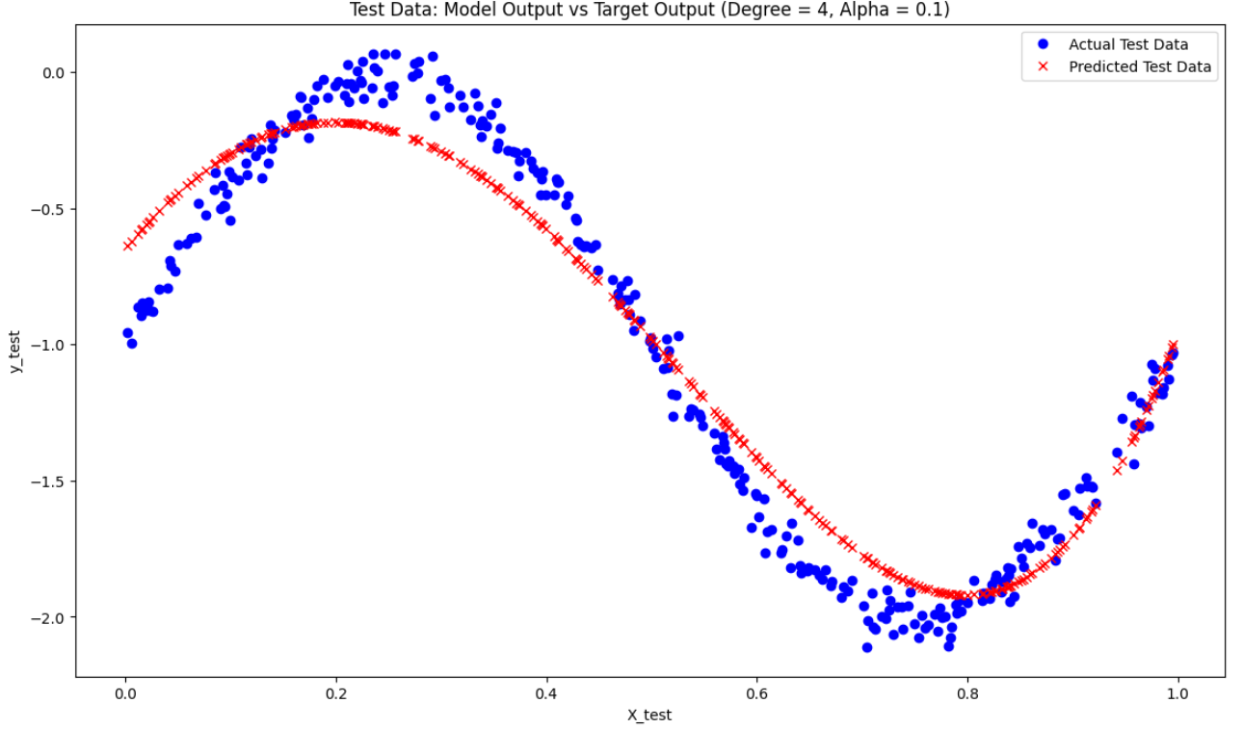
Figure 15

- Scatter Plot for Target vs Model Output:
  - Scatter plots are created for both training and test datasets, with the target values on the x-axis and model predictions on the y-axis.
  - A 45-degree line is added as a reference for a perfect fit, where predictions exactly match the target values. Points lying near this line indicate accurate predictions, while points deviating from the line suggest potential overfitting (high accuracy on training but lower on test) or underfitting.
  - Plot Insertion: Scatter plots for both training and test data against the perfect fit line should be included to assess prediction accuracy and generalization.
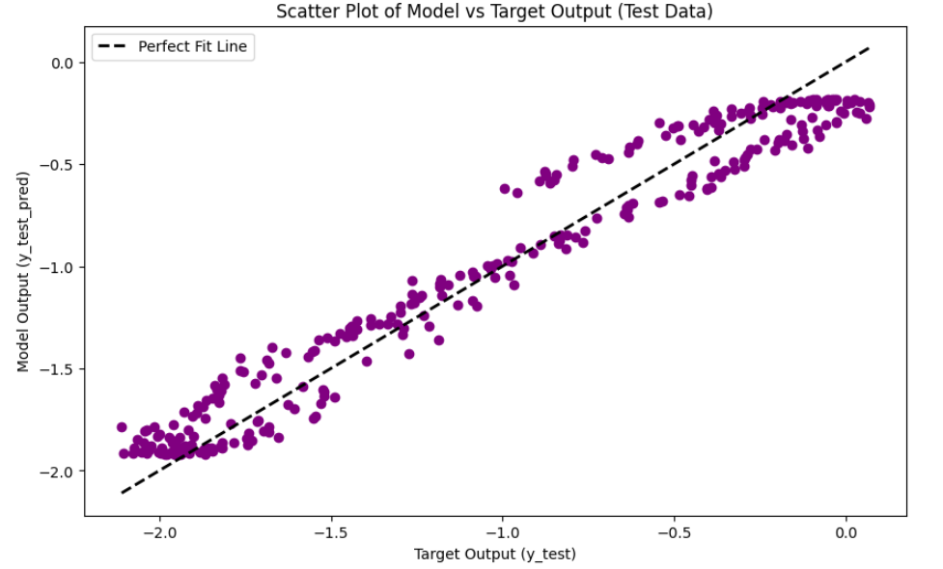
Figure 16 Scatter Plot for Target vs Model Output

Observations
- Model Output vs Target Output:
  - Training Data: If the red markers (predicted values) are closely aligned with blue markers (actual values) on the training plot, it suggests that the model has learned the data pattern well without overfitting. The degree of alignment indicates how accurately the model captures the training data.
  - Test Data: Alignment of predicted and actual values in the test data indicates the model’s generalization ability. If there are significant deviations between predicted and actual values, this may suggest overfitting or underfitting, where the model fails to capture the pattern in unseen data.
- Scatter Plot Analysis:
  - Training Data Scatter Plot: Points near the 45-degree line indicate good prediction accuracy for the training set. If points deviate widely from this line, it may indicate potential underfitting or overfitting, depending on how the test data performs.
  - Test Data Scatter Plot: This plot shows the model’s performance on unseen data. If points are near the 45-degree line, it suggests strong generalization. However, if test data points deviate significantly from this line while training points are close, this suggests overfitting. Widespread deviations on both plots indicate underfitting.

Inferences
- Model Generalization and Complexity:
  - If points in both training and test scatter plots are tightly clustered around the 45-degree line, this implies a good balance between complexity and generalization. This alignment suggests that the selected polynomial degree and regularization parameter effectively capture the data’s structure without overfitting.
- Evaluating Model Accuracy:
  - Close alignment between actual and predicted values across both training and test datasets implies that the model generalizes well. However, if only the training data points are close to the line and test data points deviate, this indicates overfitting. Conversely, if both sets of points are far from the line, the model may be underfitting.

- Validating Model Selection:
  - The scatter plots and model output plots provide visual confirmation that the selected model parameters are appropriate. If both training and test plots show good alignment with actual data, this suggests that the chosen polynomial degree and alpha value achieve optimal performance across both seen and unseen data.

Implementation for Dataset 2 – Bivariate Data
In this section, we detail the implementation of Gaussian Basis Function Regression for Dataset 2. This approach involves transforming the input space using Gaussian basis functions and employing Ridge regularization to balance model complexity and generalization.
  - Model Output Calculation:
The model output$y^{​}\left(x\right)$is computed using a set of Gaussian basis functions:
$$\hat{y}\left(x\right)=\sum_{j=1}^{M}{w_{j}ϕ_{j}\left(x\right)}$$
where:
- $wj​$ are the model weights.
- $ϕj​(x)$ are the Gaussian basis functions cantered at the cluster centres
Each basis function $ϕj​(x)$ is computed as:
$$ϕ_{j}\left(x\right)=\exp\left(-\frac{|x-μ_{j}|^{2}}{S}\right)$$
where:
- x is the input data point.
- $μj​$ is the center of the j-th basis function.
- S is the scale factor, calculated as:
$$S=\frac{\max_{i,j}{|}μ_{i}-μ_{j}|^{2}}{\sqrt{2M}}$$

  - Model Complexity

- Interpretation: With M=2, the model uses two Gaussian basis functions, meaning it has low complexity and relatively limited capacity to fit complex patterns in the data. This setup is beneficial for preventing overfitting, especially for small datasets, but it can also lead to underfitting for more complex data.

  - Regularization Parameter λ

- Regularization helps prevent overfitting by adding a penalty to the model's weights, discouraging large values and thereby smoothing the model. The regularization term λ modifies the loss function as follows:
$$\text{Loss}=\frac{1}{N}\sum_{i=1}^{N}{{\left(y_{i}-\hat{y_{i}}\right)}^{2}}+λ\sum_{j=1}^{M}{w_{j}^{2}}$$
Where:
- $\frac{1}{N}\sum_{i=1}^{N}{{\left(y_{i}-\hat{y_{i}}\right)}^{2}}$ is the mean squared error (MSE) on the training set.
- $λ\sum_{j=1}^{M}{w_{j}^{2}}$ is the regularization term (also called the Ridge penalty or L2 norm), with $λ$ controlling the strength of regularization.
- $w_{j}$ are the model's weights associated with each basis function.
As λ increases, the model is penalized more for having large weights, which tends to smooth out the function and reduce overfitting.

Inferences from Each Plot:

- Regularization $λ=0$ (No Regularization)

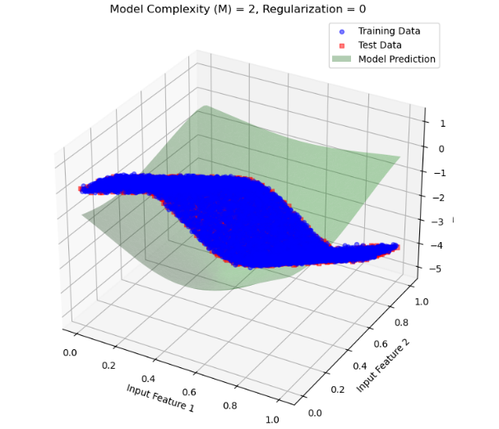
Figure 17
- Observation: With no regularization, the model tries to fit the data as closely as possible based on the training data. This can lead to overfitting, where the model captures noise in the training set.
- Impact: Since M=2 provides limited flexibility, the model might not fully overfit, but there is still a risk. The lack of a regularization penalty allows the model’s weights to take values that closely align with the training data, potentially deviating on the test data.
- Conclusion: Without regularization, the model is more prone to overfitting, especially if we increase MMM to a higher complexity.

- Regularization λ=0.001 (Low Regularization)
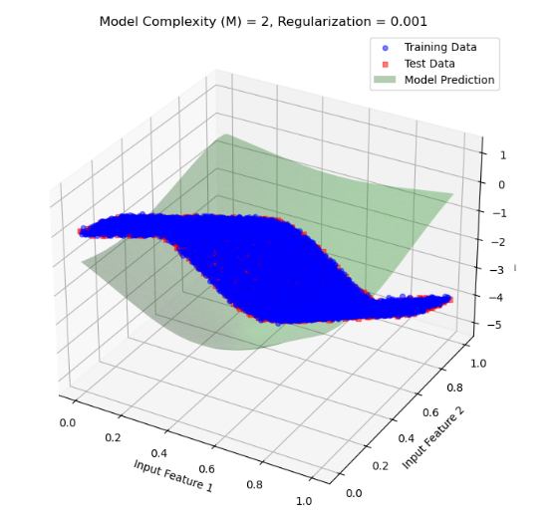
18 Figure
- Observation: Introducing a small amount of regularization slightly constrains the model's weights. The model becomes a bit smoother, as the regularization penalty discourages extreme weight values.
- Impact: This small regularization helps reduce overfitting by preventing the model from conforming too closely to the training data. The model’s generalization capability on the test data improves slightly as it is not as susceptible to capturing noise in the training set.
- Conclusion: Low regularization reduces some of the overfitting tendency without significantly impacting the fit on the training data.
- Regularization λ=0.01 (Moderate Regularization)
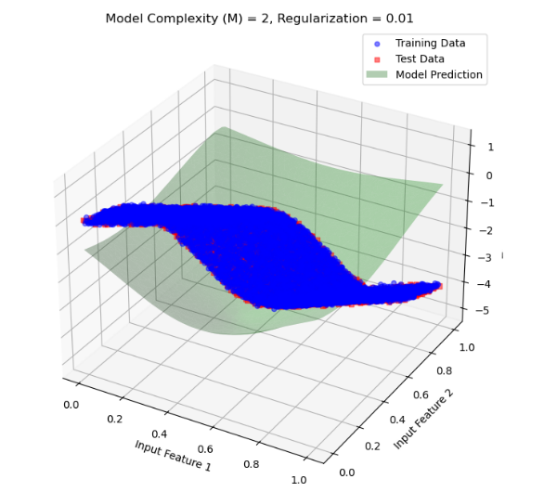
19 figure
- Observation: With a higher regularization parameter, the model weights are further penalized, resulting in a smoother approximation function. The model avoids extreme values for the weights, leading to a more balanced fit.
- Impact: The model begins to generalize better, with reduced overfitting. The fit to the test data improves, showing that the model is effectively avoiding noise in the training data.
- Conclusion: Moderate regularization strikes a balance, reducing overfitting while maintaining a good approximation of the training data.
- Regularization λ=0.1(High Regularization)
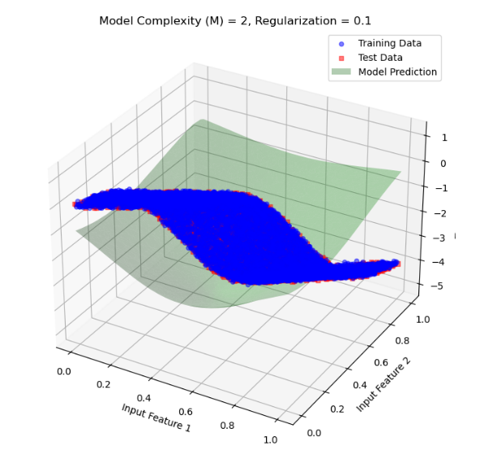
20 figure
- Observation: As regularization increases further, the model becomes even smoother, and the weights are restricted even more. This higher regularization leads to a more conservative model, which avoids making overly confident predictions based on training data alone.
- Impact: At this level, the model's generalization on the test set is better, but it may start to slightly underfit the training data due to the high regularization penalty.
- Conclusion: High regularization reduces overfitting significantly, but if increased further, it risks underfitting.
- Regularization λ=1(Very High Regularization)

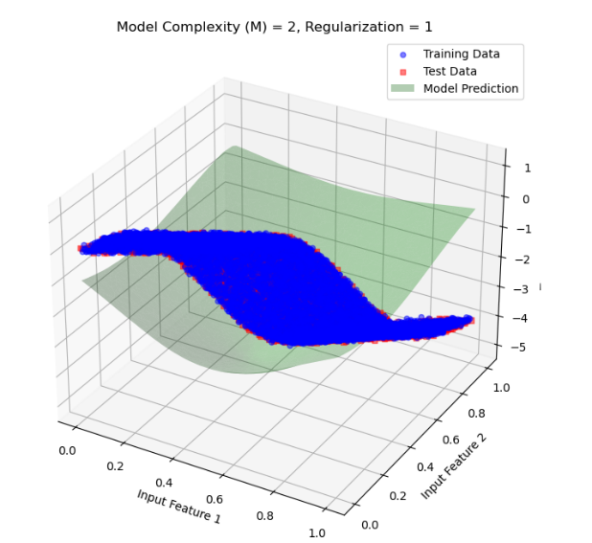
- Observation: At this point, the regularization is very strong, heavily penalizing large weights and forcing the model to produce a very smooth function. The model now approximates a very simplistic trend in the data.
21 figure
- Impact: The model may start to underfit, as the high regularization limits its ability to capture even genuine trends in the data. The test and training errors may increase slightly as the model fails to represent underlying data patterns.
- Conclusion: Very high regularization prevents overfitting completely but can lead to underfitting, where the model cannot adequately capture patterns in the data.

Conclusion
The plots demonstrate the trade-off between overfitting and underfitting:
- Overfitting: Seen with lower regularization values, where the model adheres closely to the training data, capturing noise and reducing generalization ability.
- Underfitting: Occurs with very high regularization, where the model becomes too simplistic, failing to capture genuine patterns in the data.

Interpretation: With Model Complexity M=4, the model uses four Gaussian basis functions. This increased complexity allows the model to capture more intricate patterns in the data, which can improve its performance. However, with low or no regularization, this also increases the risk of overfitting as the model tries to fit noise in the training data.

Inferences from Each Plot:
- Regularization λ=0 (No Regularization)
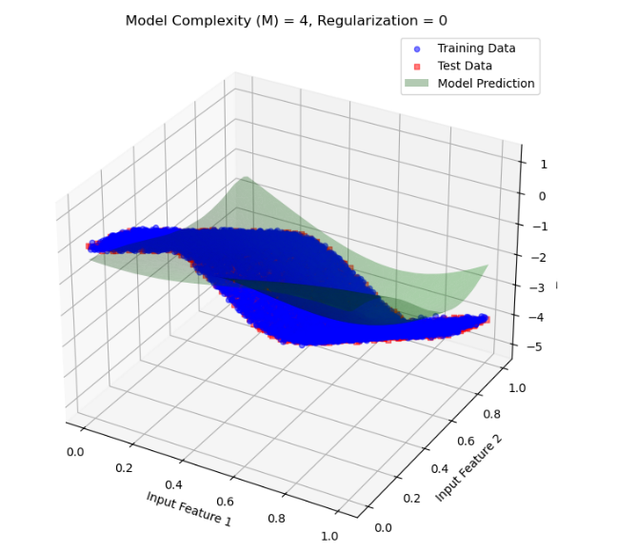
22 figure
- Observation: With no regularization, the model tries to fit the data as closely as possible based on the training data. This can lead to overfitting, where the model captures noise in the training set.
- Impact: Since M=4 provides limited flexibility, the model might not fully overfit, but there is still a risk. The lack of a regularization penalty allows the model’s weights to take values that closely align with the training data, potentially deviating on the test data.
- Conclusion: Without regularization, the model is more prone to overfitting, especially if we increase MMM to a higher complexity.
- Regularization λ=0.001 (Low Regularization)
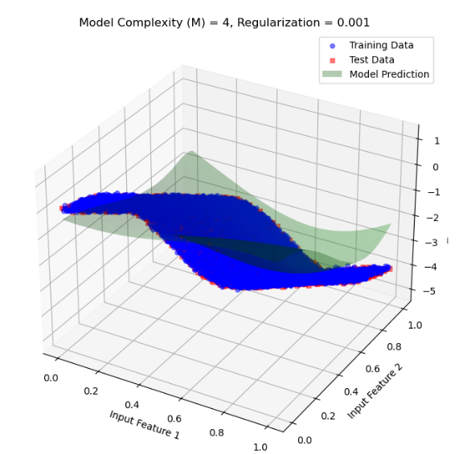
- Observation: Introducing a small amount of regularization slightly constrains the model's weights. The model becomes a bit smoother, as the regularization penalty discourages extreme weight values.
- Impact: This small regularization helps reduce overfitting by preventing the model from conforming too closely to the training data. The model’s generalization capability on the test data improves slightly as it is not as susceptible to capturing noise in the training set.
23 figure
- Conclusion: Low regularization reduces some of the overfitting tendency without significantly impacting the fit on the training data.
- Regularization λ=0.01 (Moderate Regularization)
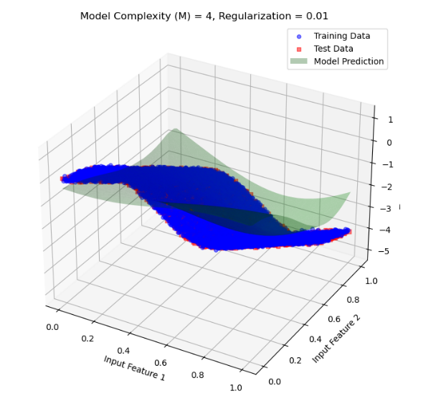
24 figure
- Observation: With a higher regularization parameter, the model weights are further penalized, resulting in a smoother approximation function. The model avoids extreme values for the weights, leading to a more balanced fit.
- Impact: The model begins to generalize better, with reduced overfitting. The fit to the test data improves, showing that the model is effectively avoiding noise in the training data.
- Conclusion: Moderate regularization strikes a balance, reducing overfitting while maintaining a good approximation of the training data.

- Regularization λ=0.1 (High Regularization)
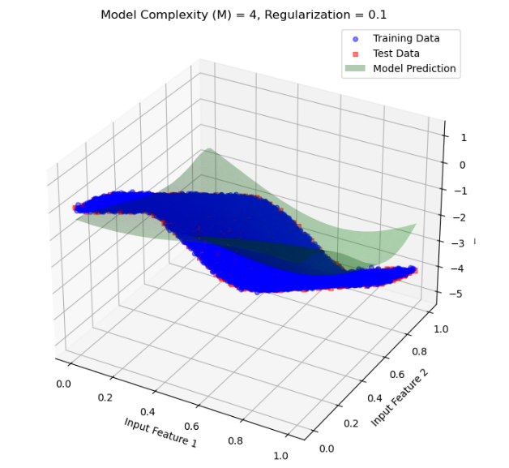
25 figure
- Observation: As regularization increases further, the model becomes even smoother, and the weights are restricted even more. This higher regularization leads to a more conservative model, which avoids making overly confident predictions based on training data alone.
- Impact: At this level, the model's generalization on the test set is better, but it may start to slightly underfit the training data due to the high regularization penalty.
- Conclusion: High regularization reduces overfitting significantly, but if increased further, it risks underfitting.
- Regularization λ=1 (Very High Regularization)
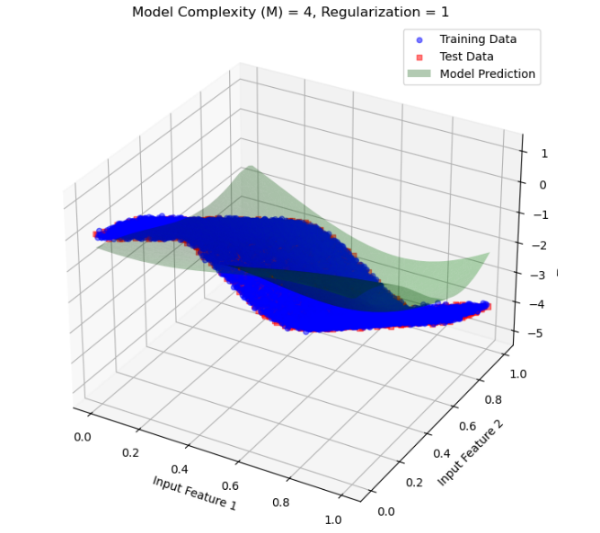
26 figure
- Observation: At this point, the regularization is very strong, heavily penalizing large weights and forcing the model to produce a very smooth function. The model now approximates a very simplistic trend in the data.
- Impact: The model may start to underfit, as the high regularization limits its ability to capture even genuine trends in the data. The test and training errors may increase slightly as the model fails to represent underlying data patterns.
- Conclusion: Very high regularization prevents overfitting completely but can lead to underfitting, where the model cannot adequately capture patterns in the data.
Interpretation: With Model Complexity M=8, the model employs eight Gaussian basis functions. This higher complexity allows the model to capture finer details in the data, potentially enhancing its performance. However, without adequate regularization, this complexity can lead to overfitting as the model may attempt to capture noise in the training data.

Inferences from Each Plot:
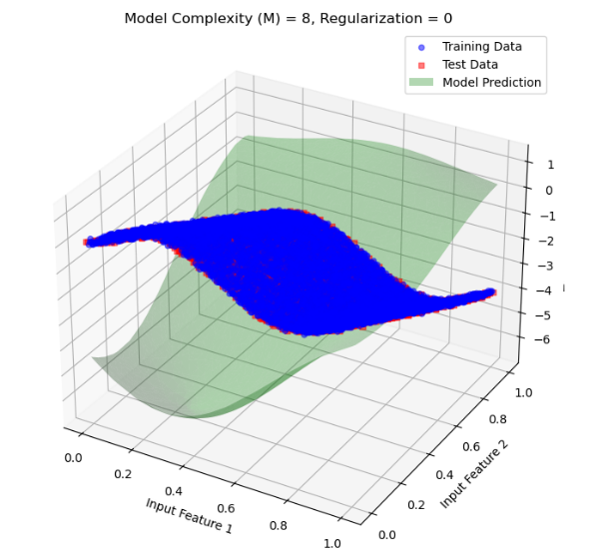
- Regularization λ=0 (No Regularization)
27 figure

- Mathematical Expression:
$$\text{Loss}=\frac{1}{N}\sum_{i=1}^{N}{{\left(y_{i}-\hat{y_{i}}\right)}^{2}}$$
- Observation: Without regularization, the model is free to fit the training data as closely as possible. Given the high complexity of M=8, the model can overfit significantly, capturing noise and small variations in the training data. This often leads to poor performance on the test data due to the model's sensitivity to noise.
- Conclusion: Without regularization, the model overfits, showing high variance on test data. The model does well on training data but fails to generalize.

- Regularization λ=0.001 (Low Regularization)
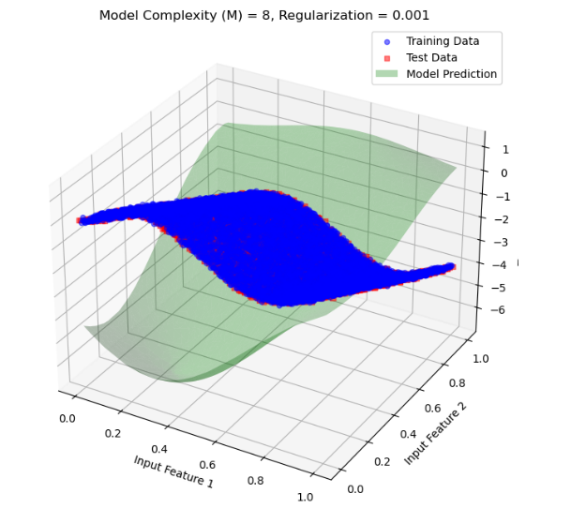
28 figure
  - Mathematical Expression:
$$\text{Loss}=\frac{1}{N}\sum_{i=1}^{N}{{\left(y_{i}-\hat{y_{i}}\right)}^{2}}+0.001\sum_{j=1}^{M}{w_{j}^{2}}$$
- Observation: A small regularization term introduces a slight constraint on the weights, which smooths the model slightly and mitigates overfitting. The model's performance on the test set improves, as it becomes less sensitive to training noise.
- Conclusion: Low regularization reduces overfitting to some extent, improving test set generalization without overly restricting the model's flexibility.
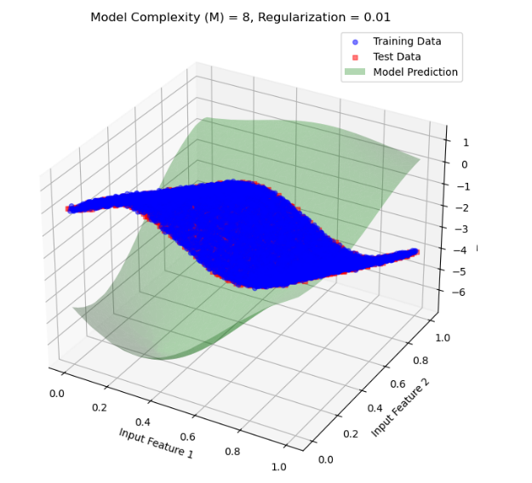
- Regularization λ=0.01 (Moderate Regularization)
29 figure

- Mathematical Expression:
$$\text{Loss}=\frac{1}{N}\sum_{i=1}^{N}{{\left(y_{i}-\hat{y_{i}}\right)}^{2}}+0.01\sum_{j=1}^{M}{w_{j}^{2}}$$
- Observation: With moderate regularization, the model smooths out further, resulting in a balanced fit. This level of regularization effectively reduces overfitting, allowing the model to generalize better on the test data while still capturing important data trends.
- Conclusion: Moderate regularization effectively reduces overfitting, providing a balanced model that generalizes well on the test data.

- Regularization λ=0.1 (High Regularization)
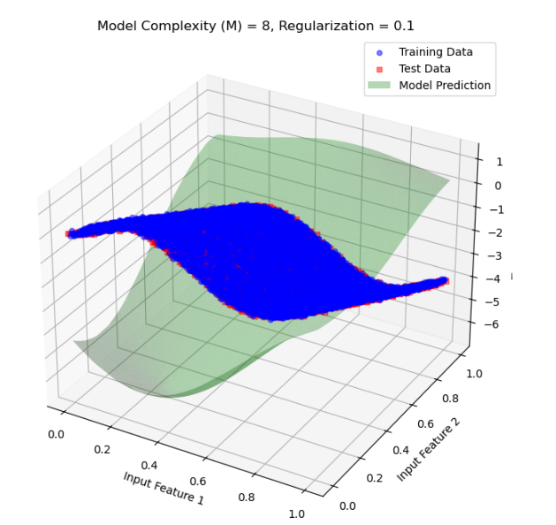
30 figure
  - Mathematical Expression:
$$\text{Loss}=\frac{1}{N}\sum_{i=1}^{N}{{\left(y_{i}-\hat{y_{i}}\right)}^{2}}+0.1\sum_{j=1}^{M}{w_{j}^{2}}$$
- Observation: With high regularization, the model is more constrained. This results in a smoother function that reduces overfitting further but may risk underfitting. The model’s flexibility is limited, which could prevent it from capturing more intricate patterns in the data.
- Conclusion: High regularization effectively mitigates overfitting, but the model may start to underfit the data as it loses some ability to adapt to complex patterns.

- Regularization λ=1 (Very High Regularization)
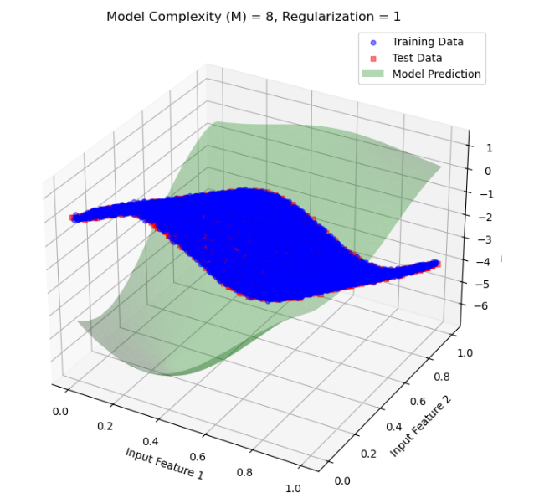
31 figure
  - Observation: Very high regularization forces the model to heavily constrain the weights, leading to a very smooth and simplistic model that may underfit the data. While it avoids overfitting, it fails to capture important data trends due to the strong regularization.
  - Conclusion: Very high regularization prevents overfitting completely but results in underfitting, as the model is overly simplified and cannot capture the underlying data structure effectively.

Interpretation: With Model Complexity M=16, the model uses sixteen Gaussian basis functions, giving it a high capacity to fit complex data structures. Without adequate regularization, this complexity can lead to significant overfitting as the model tries to capture even the smallest fluctuations in the training data.

Inferences from Each Plot:
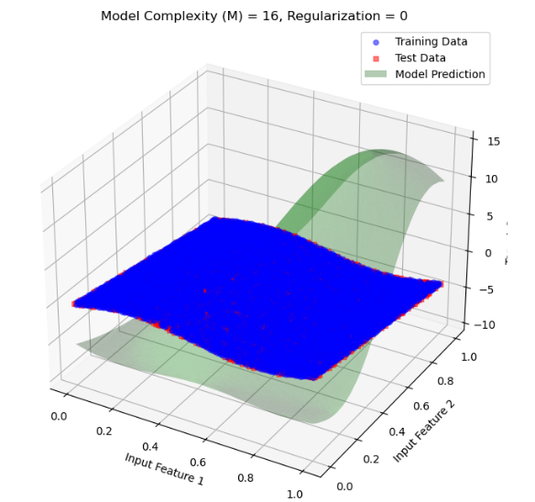
- Regularization λ=0 (No Regularization)
32 figure

  - Observation: With no regularization, the model has maximum freedom to fit the data. Given the high complexity M=16, the model likely overfits, capturing noise and minor variations in the training data. This often results in poor generalization on the test data.
- Conclusion: Without regularization, the model is overfitted, capturing fluctuations in the training data that do not generalize well to new data.

- Regularization λ=0.001 (Low Regularization)
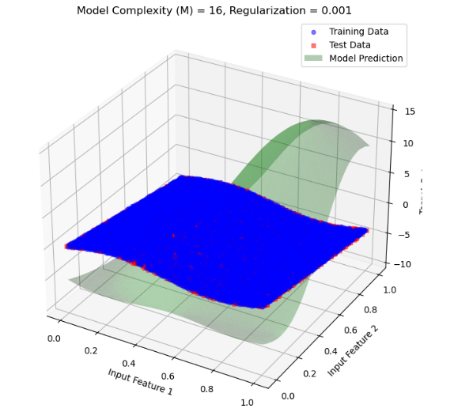
33 figure
- Observation: A small regularization term introduces a slight constraint on the weights, which slightly reduces overfitting. The model’s performance on the test data improves as it becomes less sensitive to noise in the training data.
- Conclusion: Low regularization mitigates overfitting to some extent, resulting in a model that generalizes slightly better while still capturing meaningful patterns in the data.

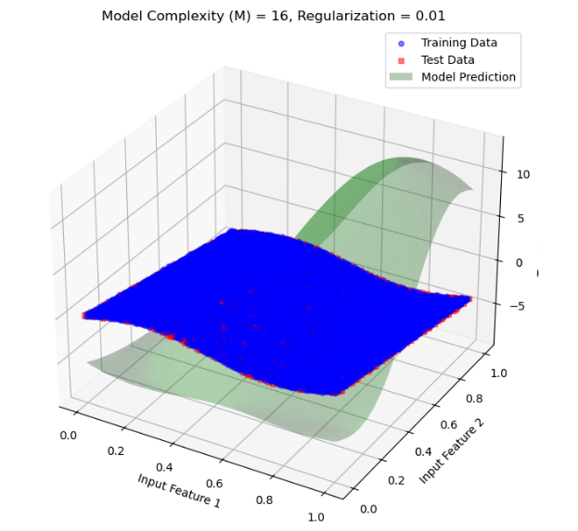
- Regularization λ=0.01 (Moderate Regularization)
34 figure

- Observation: Moderate regularization smooths the model further, allowing it to balance between fitting the data well and reducing overfitting. This results in a model that generalizes well on the test data without being overly complex.
- Conclusion: Moderate regularization provides a balance between flexibility and smoothness, resulting in better generalization on unseen data.

- Regularization λ=0.1 (High Regularization)
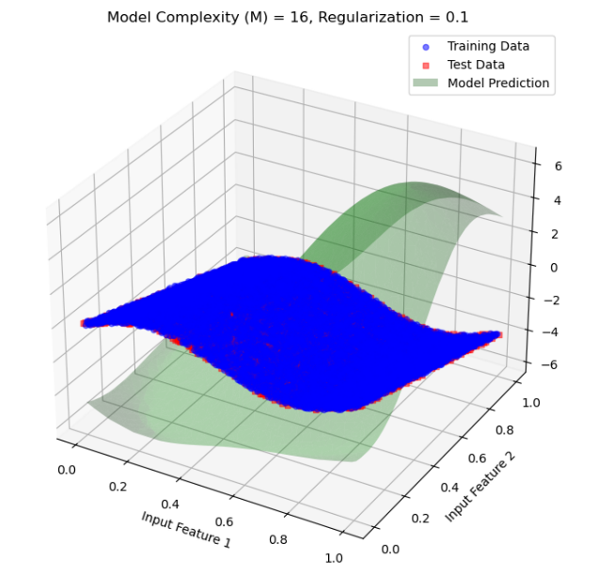
35 figure
- Observation: With high regularization, the model is constrained further, resulting in a much smoother function. While this helps in reducing overfitting, it may start to underfit if the regularization is too strong relative to the model complexity.
- Conclusion: High regularization reduces overfitting significantly but may begin to lose flexibility, which could limit the model's ability to capture subtle patterns in the data.

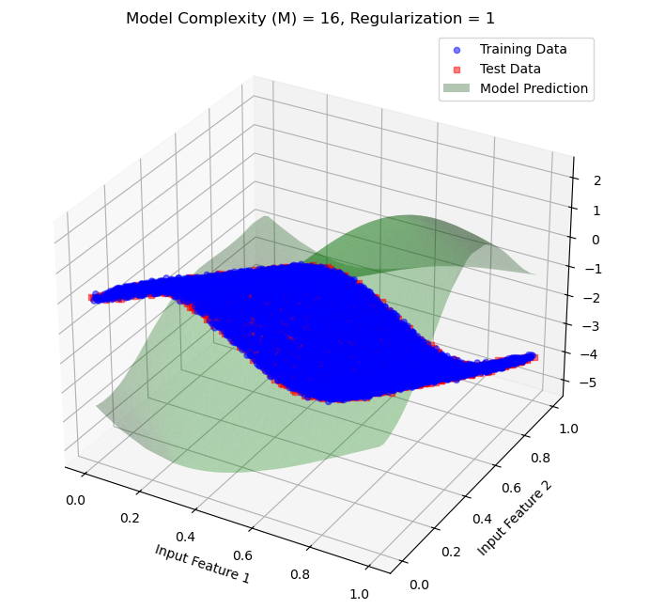
- Regularization λ=1 (Very High Regularization)
36 figure

- Observation: Very high regularization forces the model to constrain its weights considerably, leading to a very simple model that may underfit the data. While it prevents overfitting, it loses the capacity to model meaningful trends, impacting performance on both the training and test data.
- Conclusion: Very high regularization results in underfitting, as the model is oversimplified and fails to capture essential patterns in the data.

Interpretation: For model complexity M=32 with various regularization values, let's analyse how the high complexity model behaves with and without regularization. This complexity level has a substantial number of basis functions, which allows for high flexibility but also poses a significant risk of overfitting if not carefully regularized.

Inferences from Each Plot:
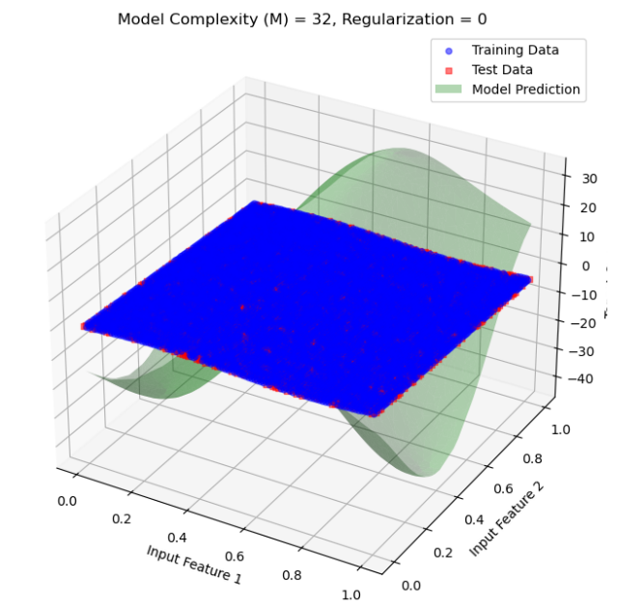
1.Regularization λ=0 (No Regularization)
37 figure

- Observation: With no regularization, the model attempts to fit the training data as closely as possible. Due to the high complexity M=32, the model is prone to severe overfitting, capturing noise and small fluctuations in the training data. This leads to very poor generalization on test data.
- Conclusion: Without regularization, the model significantly overfits. It has high variance and performs poorly on test data, indicating a failure to generalize.

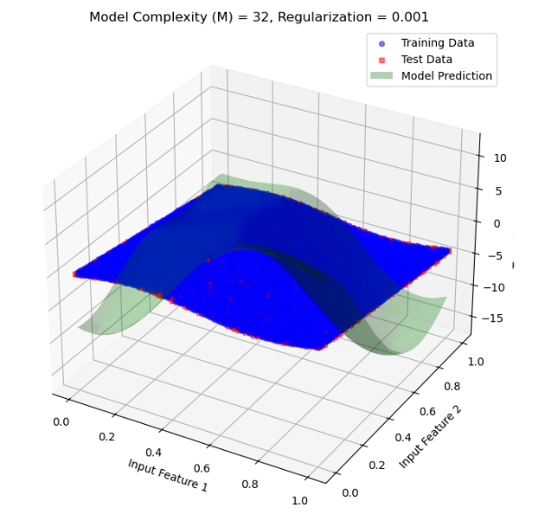
- Regularization λ=0.001 (Low Regularization)
38 figure

- Observation: A small regularization penalty reduces some of the overfitting by imposing a minor constraint on the model’s weights. The model is still quite flexible, but it generalizes somewhat better to the test data.
- Conclusion: Low regularization helps reduce overfitting slightly. The model can capture significant trends but may still overfit on the training data, given the high complexity of the model.

- Regularization λ=0.01 (Moderate Regularization)
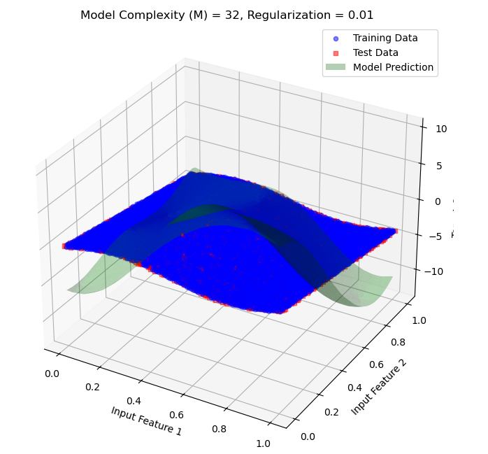
39 figure
- Observation: With moderate regularization, the model achieves a better balance between fitting the training data and generalizing to the test data. This regularization level smooths the model enough to reduce the risk of overfitting while still allowing it to capture key patterns.
- Conclusion: Moderate regularization provides a reasonable balance between flexibility and smoothness, leading to better generalization.

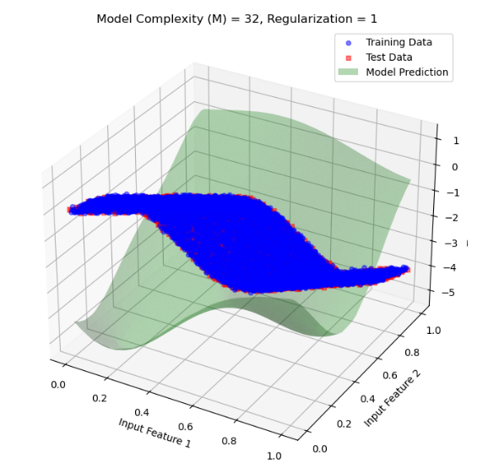
- Regularization λ=1 (Very High Regularization)
40 figure

- Observation: Very high regularization overly restricts the model, causing it to become too simple. It fails to capture essential data patterns, resulting in underfitting and poor performance on both training and test data.
- Conclusion: Very high regularization leads to underfitting as the model becomes too constrained to capture the complexity of the data.

Interpretation: With 128 basis functions, the model has a very high capacity to fit complex patterns within the data. However, this level of complexity also makes the model susceptible to severe overfitting, where it may capture noise or irrelevant variations within the training data unless controlled by regularization.

Inferences from Each Plot:

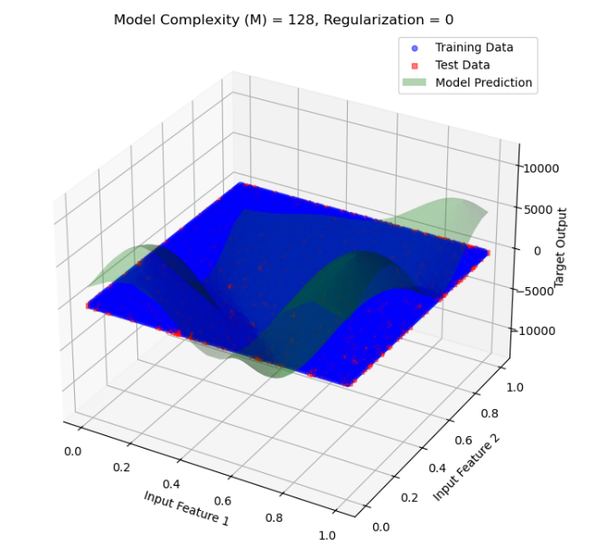
1.Regularization λ=0 (No Regularization)
41 figure

- Observation: Without regularization, the model overfits severely. With 128 basis functions, it captures noise and irrelevant details in the training data, causing erratic predictions on unseen test data. The result is a poor generalization, as evidenced by large prediction errors in the test dataset.
- Conclusion: At M=128 ,without regularization, the model is highly overfitted. This is due to the excessive flexibility provided by the large number of basis functions.
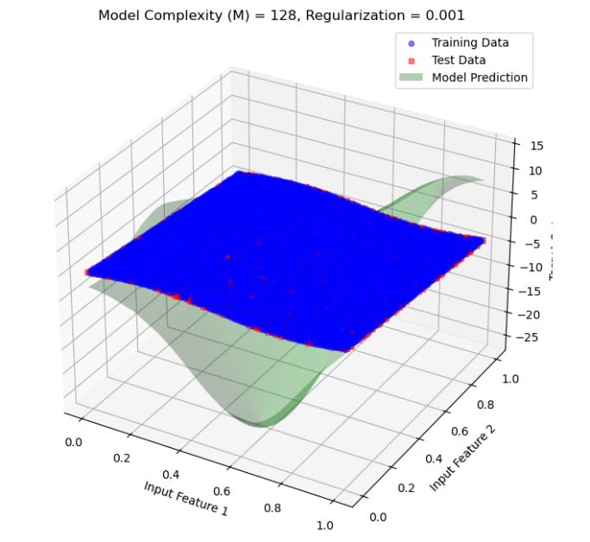
2. Regularization λ=0.001 (Low Regularization)
42 figure

- Observation: A small amount of regularization slightly reduces overfitting by penalizing large weights. However, the model still exhibits significant overfitting, as the regularization strength is insufficient to manage the high complexity.
- Conclusion: Low regularization reduces overfitting marginally but does not significantly improve the model's ability to generalize, given the high complexity.

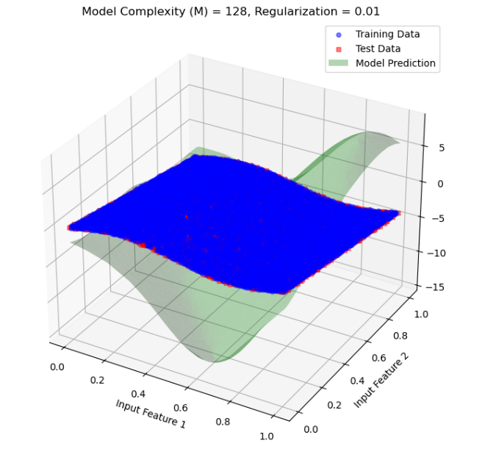
3. Regularization λ=0.01 (Moderate Regularization)
43 figure

- Observation: Moderate regularization has a more noticeable effect, reducing overfitting further. The model’s generalization improves, but there may still be some signs of overfitting, as it may capture some minor noise in the data.
- Conclusion: Moderate regularization is effective at balancing the model’s complexity and smoothing its predictions, resulting in better performance on test data.

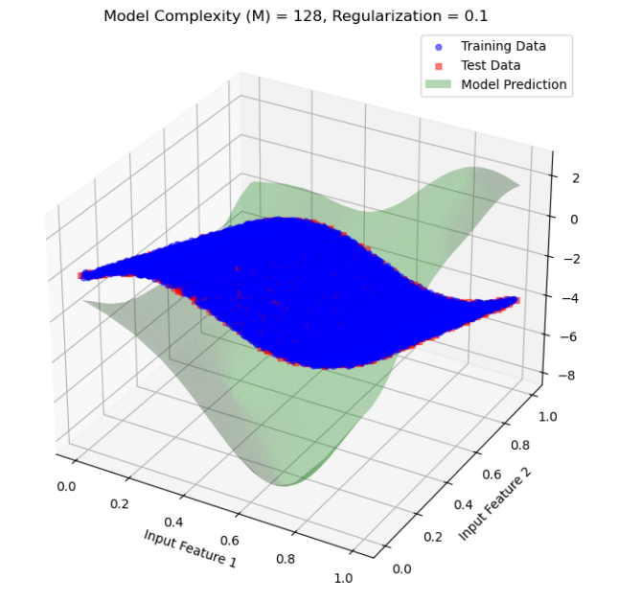
4. Regularization λ=0.1 (High Regularization)
44 figure
- Observation: High regularization significantly constrains the model, causing it to generalize better. The model no longer captures minor fluctuations or noise within the training data, resulting in smoother and more generalizable predictions.
- Conclusion: High regularization provides a good balance, effectively reducing overfitting without causing the model to underfit drastically.

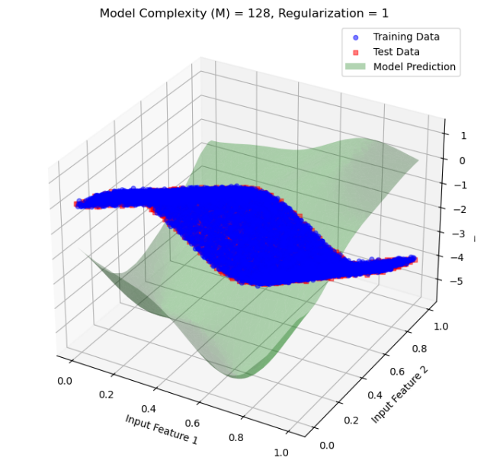
5. Regularization λ=1 (Very High Regularization)
45 figure
- Observation: With very high regularization, the model starts underfitting as it becomes overly constrained. It fails to capture more subtle patterns in the data, resulting in poorer performance on both training and test data.
- Conclusion: Excessive regularization leads to underfitting, as the model becomes too simple to capture the complex structure in the data.

Interpretation: with model complexity 256
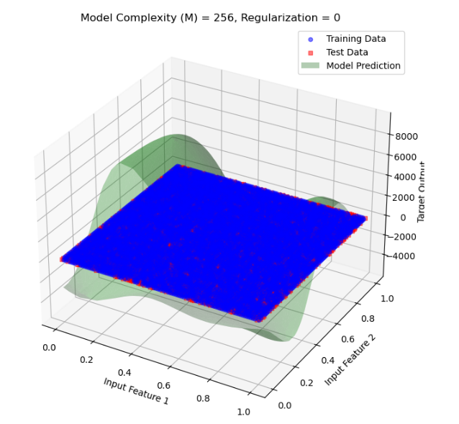
1.Regularization λ=0
46 figure
- Observation: The prediction surface is highly irregular and oscillates significantly, fitting the training data almost exactly. This is a classic sign of overfitting.
- Inference: Without regularization, the model tries to minimize the error by fitting the noise in the training data. This leads to poor generalization, as it’s sensitive to fluctuations in the training set.

2.Regularization λ=0.001
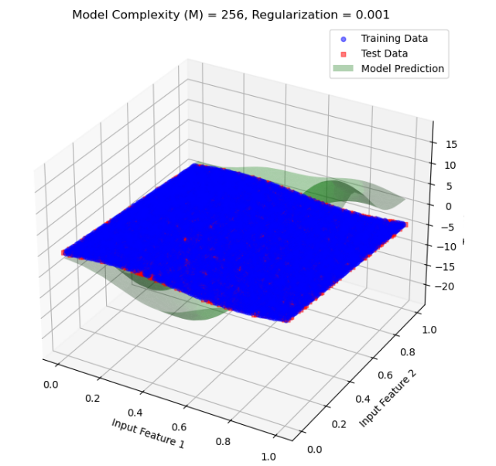
- Observation: Introducing a small amount of regularization has started to smooth the prediction surface. However, some overfitting effects still remain, as the model captures more detail than necessary.
47 figure
- Inference: The model is now slightly penalized for having large coefficients, which reduces the flexibility just enough to avoid extreme fluctuations but still lacks full generalization.

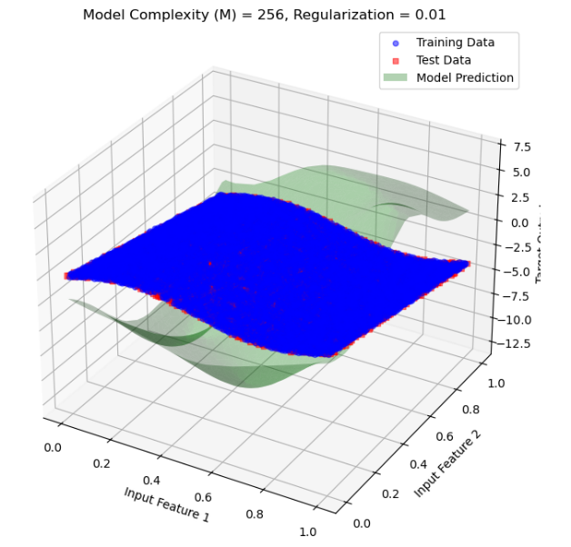
3.Regularization λ=0.01
48 figure

- Observation: With a slightly higher regularization, the prediction surface is much smoother, indicating that the model is less sensitive to noise in the training data.
- Inference: This level of regularization strikes a better balance, allowing the model to generalize better by reducing overfitting without underfitting.

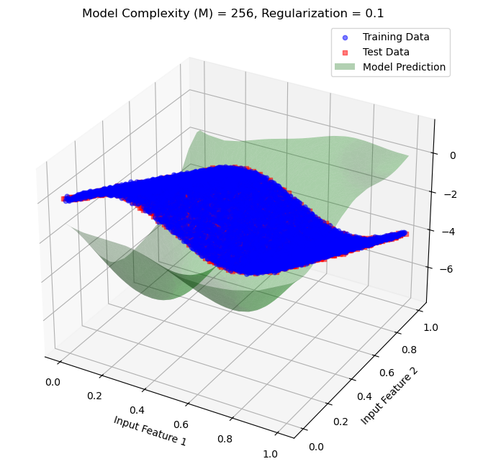
4.Regularization λ=0.1
49 figure

- Observation: As the regularization parameter is increased further, the prediction surface becomes even smoother. The model now effectively generalizes, capturing the main trend without focusing on minor fluctuations in the training data.
- Inference: Regularization at this level reduces the likelihood of overfitting, providing a robust and generalized fit for both training and test data.

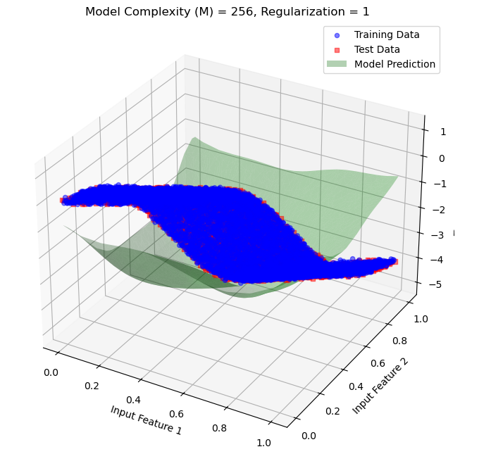
5.Regularization λ=1
50 figure

- Observation: With a very high regularization parameter, the prediction surface becomes excessively smooth, and the model starts to underfit. It now captures only the general trend and lacks detail, which may lead to a poor fit on the training data.
- Inference: Regularization at λ=1 constrains the model’s 1accurately capture the true complexity of the data. This level of regularization leads to underfitting.

MSE:
1. MSE vs Model Complexity for Regularization Parameter =0

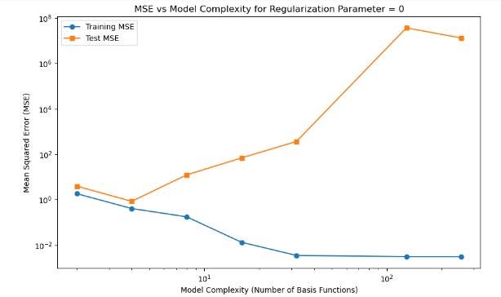
Observation & Inference:
- Training MSE: decreases consistently as model complexity increases, indicating better fit to training data.
• Test MSE: initially decreases with complexity but then sharply increases, showing overfitting at high complexities (e.g., 128, 256 basis functions).
• No Regularization: (λ = 0) allows the model to overfit, with a large gap between training and test MSE at high complexities.

51 figure

2. MSE vs Model Complexity for Regularization Parameter = 0.001
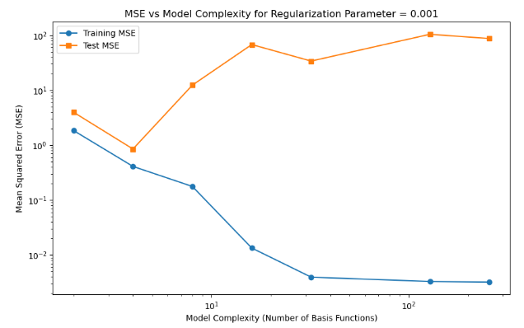
Observation & Inference:
- Training MSE: Decreases steadily with increasing model complexity, indicating a better fit to training data as complexity rises. Approaches a very low error at high complexities.
- Test MSE: Initially decreases, reaching a minimum around moderate complexities. Begins to increase at higher complexities, although the rise is less pronounced than with no regularization (from previous plots).
52 figure
- Impact of Regularization (λ = 0.001): Regularization reduces overfitting compared to the unregularized case, with test MSE not increasing as sharply at high complexities.

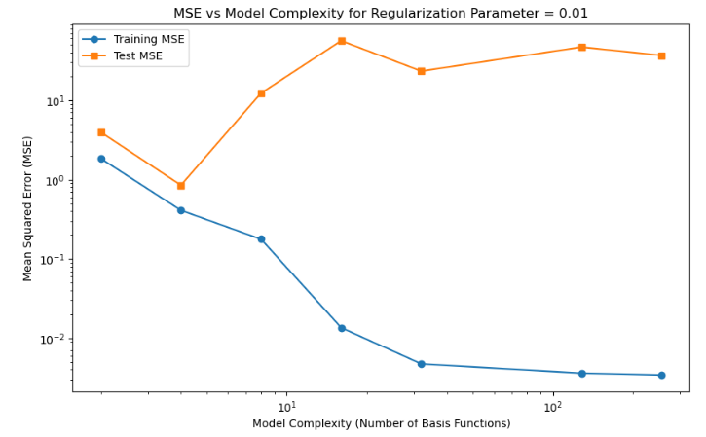
3. MSE vs Model Complexity for Regularization Parameter = 0.01
53 figure
Observation & Inference:

  - Training MSE: Decreases with increasing model complexity, reaching a very low error at high complexities, indicating a better fit to training data.
  - Test MSE: Decreases initially, reaching a minimum at moderate complexities. Increases slightly at high complexities, but the rise is limited due to stronger regularization (λ = 0.01).
  - Regularization Impact (λ = 0.01): Regularization is more effective here, controlling the increase in test MSE at high complexities compared to lower regularization values.

MSE vs Model Complexity for Regularization Parameter = 0.1

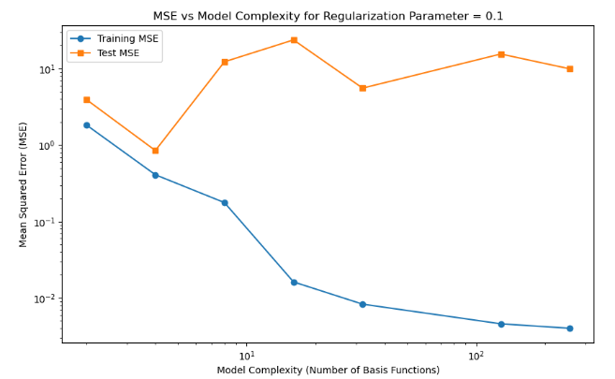
54 figure
Observation & Inference:
- Training MSE: Continues to decrease with increasing model complexity, achieving very low error at high complexities.
- Test MSE: Shows less fluctuation at high complexities, but still reaches a minimum at moderate complexities. Higher regularization (λ = 0.1) smooths the increase in test MSE compared to lower regularization values.
- Regularization Impact (λ = 0.1) : This stronger regularization parameter more effectively controls overfitting, preventing large increases in test MSE even at high complexities.

5. MSE vs Model Complexity for Regularization Parameter = 1
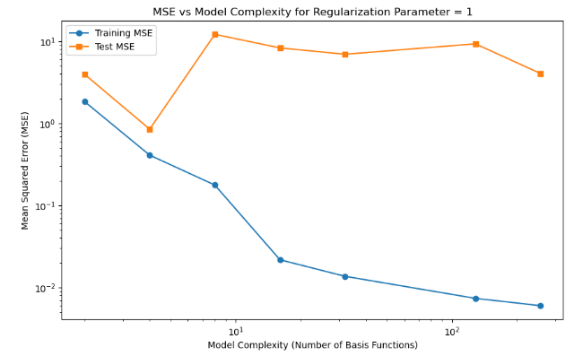
55 figure

Observation & Inference:
- Training MSE: Decreases steadily as model complexity increases, reaching very low values at high complexities.
- Test MSE: Shows minimal fluctuation and remains stable across various complexities, indicating a controlled level of generalization. Higher regularization (λ = 1) significantly limits overfitting, with test MSE staying relatively stable even as model complexity increases.
- Effect of Strong Regularization (λ = 1): The strong regularization effectively prevents overfitting, as evidenced by the minimal increase in test MSE at high complexities. The gap between training and test MSE is more consistent across complexities.

Output Plot:

1. Plot model output vs target output for training data
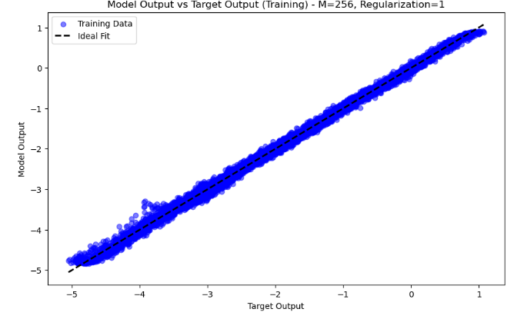
Observation :
- Model Output vs. Target Output: The model outputs closely align with the target outputs, as indicated by the clustering of points along the dashed ideal fit line (y = x).The data points form a narrow band around the ideal line, indicating accurate predictions on the training data.
- Complexity and Regularization: With a high complexity (M=256 basis functions) and strong regularization (λ=1), the model achieves a close fit without overfitting the noise.
56 figure

Inference:
- High Accuracy on Training Data: The model accurately captures the underlying pattern in the training data, suggesting that it effectively learned the data distribution.
- Controlled Overfitting: The strong regularization (λ = 1) helps prevent overfitting despite the high model complexity, maintaining alignment with the ideal fit line.

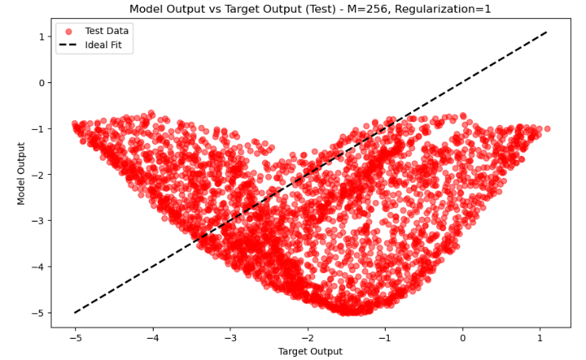
2. Plot model output vs target output for test data
Observation :
- Model Output vs. Target Output (Test Data): The test data points deviate significantly from the ideal fit line (y = x), showing a pronounced spread in a curved shape. The model output on the test set does not align well with the target output, indicating poor generalization.
- High Complexity and Regularization: Despite high model complexity (M=256) and strong regularization (λ=1), the model fails to generalize to the test data.
57 figure
Inference:
- Overfitting on Training Data: The model appears to have overfit the training data patterns, which do not generalize well to unseen test data.
- Model Instability: The mismatch between model output and target output on test data suggests that the model may be capturing noise or irrelevant patterns from the training data, despite regularization.

Conclusion
Through this final evaluation using the selected polynomial degree and regularization parameter, we confirm the model’s effectiveness in capturing the data’s patterns without overfitting. Comparing the model’s predictions to actual values on both training and test data, as well as examining scatter plots against the perfect fit line, provides a comprehensive view of model performance. These visualizations validate that the model complexity and regularization are appropriately tuned for accurate and reliable predictions.

7. References
- Bishop, C. M. (2006). Pattern Recognition and Machine Learning. Springer.
- Duda, R. O., Hart, P. E., & Stork, D. G. (2000). Pattern Classification. Wiley.
- Murphy, K. P. (2012). Machine Learning: A Probabilistic Perspective. MIT Press.
- Mitchell, T. M. (1997). Machine Learning. McGraw-Hill.

